The Ethnic Studies Program of Santa Clara University
Proudly Presents its Third Annual

Ethnic Studies Distinguished Alumni Speaker Series:
Transforming Our Lives, Transforming Our Community

Alicia Gallegos
(SCU Class of 1999)
Principal, Downtown College Prep
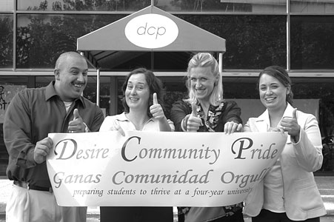

From Risk to Success:
Immigrant Students and the Local Charter Movement

Thursday, May 14, 2009
10am to 11:30am
Williman Room, Benson Center

Food and Light Refreshments Provided after Talk
Please RSVP to Pauline Nguyen by May 8th at ppnguyen@scu.edu

Downtown College Prep is the first charter high school in Silicon Valley whose mission is to prepare underachieving students to be the first in their families to thrive in college.
This talk will discuss how the school’s mission pertains to recent immigrants and their children, the myriad of student challenges, and their need for more critical work skills. Ms. Gallegos will share her many experiences about these topics and discuss the implications of the local charter movement on the California education system.

In compliance with the ADA 504, please direct your accommodation requests at least 72 hours prior to the event
to the Ethnic Studies Program at 408-554-4472.
This talk is co-sponsored by the Office for Multicultural Learning-Office of the Provost.

