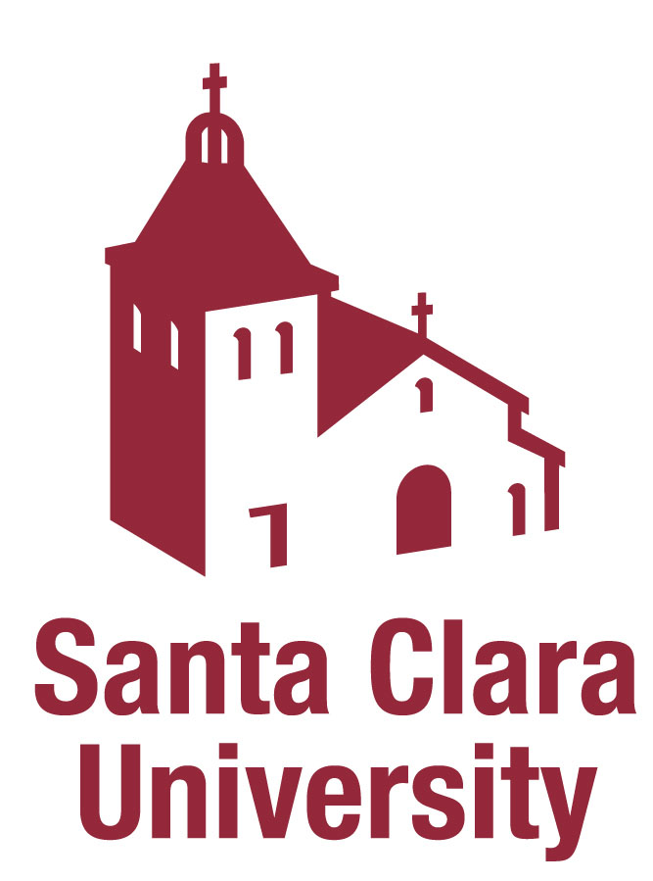
Office of ________________
Confidentiality Agreement

In accordance with California and federal law, the Department of ________ at Santa Clara University (the “Department”) is committed to safeguarding Confidential Information. By virtue of my position I understand that I may have access to Confidential Information. Confidential Information includes, but is not limited to, personnel records and working files of prospective, current, and former students, employees, data, information, and communications regarding Department and Santa Clara University business, finance, and operations. I acknowledge that as a condition of my employment, I am obligated to safeguard and not disclose the University’s Confidential Information.

As an employee in the Department I understand that I am obligated to maintain the strict confidentiality of all Confidential Information I receive or become aware of by virtue of my position in the Department. I will not disclose, discuss or provide any Confidential Information, or any aspect of such information, with anyone except those individuals who have a legitimate reason to know such information. I further agree to take all necessary precautions to ensure the all materials constituting or containing Confidential Information are maintained in a secure manner.

I understand that any unauthorized accessing and/or disclosure of Confidential Information is prohibited by this Agreement and may be a violation of state and federal law. I further understand that such violation may result in disciplinary action, up to and including termination.

____________________________________ ____________
EMPLOYEE SIGNATURE DATE

____________________________________
PRINTED NAME

