Schedule a Tuberculosis (TB) Skin Test Appointment:
https://www.signupgenius.com/go/10C0945AAAE2AA3FFC34-55523243-tuberculosis

TB Skin Testing will take place on Tuesday 4/8/25 and Wednesday 4/9/25 at the Cowell Health Center.

TB Skin Testing ($10.00 charge to students)
- Sign up for your TB Skin test and attend your scheduled TB Skin test appointment.

- Attend your TB Skin reading appointment 48-72 hours after your TB Skin test is complete. TB Skin reading appointments will be set up with the Cowell Health Center. Failure to attend either part of the test will result in an invalid test and you will incur financial penalties that will not be covered by SCU or the Arrupe Engagement Program.



Schedule a Tuberculosis (TB) Blood Test Appointment:
https://www.signupgenius.com/go/10C0945AAAE2AA3FFC34-55522566-tuberculosis

TB Blood Testing will take place on Friday 4/4/25, Monday 4/7/25, and Thursday 4/10/25 at the Cowell Health Center.

TB Blood Testing ($50.00 charge to students)
- A TB Blood test is best for SCU students who have received the BCG Vaccine. TB Blood testing is a one step process. Students attend their appointment and are emailed the results.

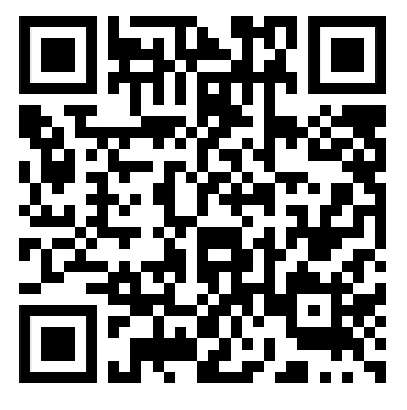

CATHOLIC SCHOOLS ONLY!
Schedule a fingerprinting appointment:
https://www.signupgenius.com/go/10C0945AAAE2AA3FFC34-55517421-elsj

SCU students who are registered to engage with a Catholic School must complete a fingerprinting background check.

- When/Where? Spring Quarter Week 1- Friday 4/4/25 from 9am-2pm in person in SCU’s Nobili Dining Room.

- Unable to make it? If students are unable to make it on Friday 4/4/25, they are responsible to get this requirement done at the fingerprinting Verify Group office (262 E Hamilton Ave Suite A, Campbell, CA 95008). Please call to make an appointment (408) 761-2156.

- Expenses/Charges: Fingerprinting background checks for students engaging with Catholic Schools are free if students go through the Verify Group. Students must communicate with the Verify Group staff that all charges must be made to SCU Arrupe Engagement Program. If students pay out of pocket, unfortunately there will be no reimbursement issued.

- Materials to bring: completed Live Scan fingerprinting form which can be located in the student’s Arrupe Engagement Confirmation Email or provided by their ELSJ professor and a valid photo ID.

