Campus Recreation Annual Report

2022 - 2023

Malley Center Check-in Data
248,389 Total Check-ins July ‘22 - June ‘23
35.72% increase in Check-ins from July ‘21 - June ‘22

Daily Usage
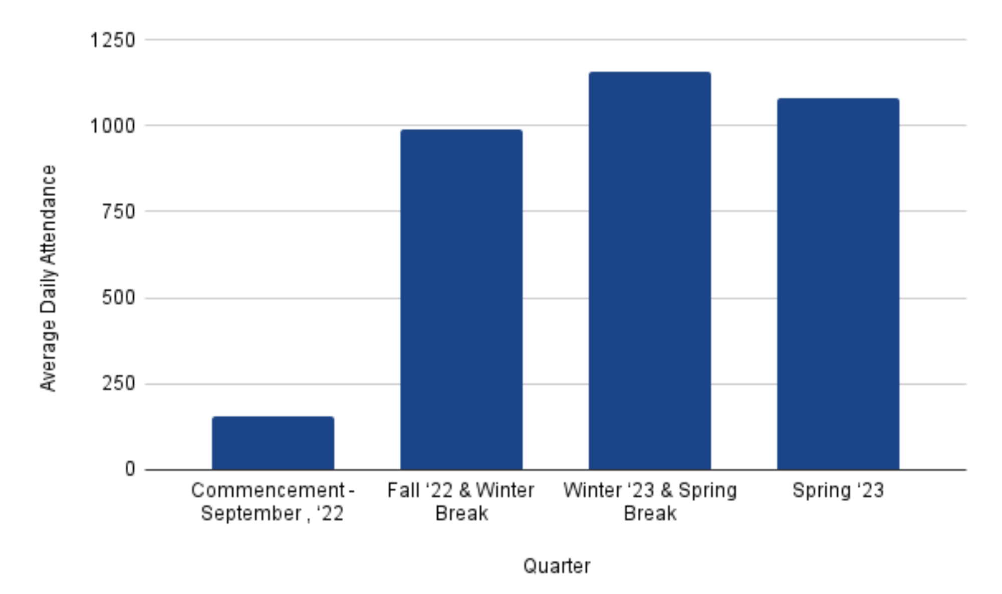

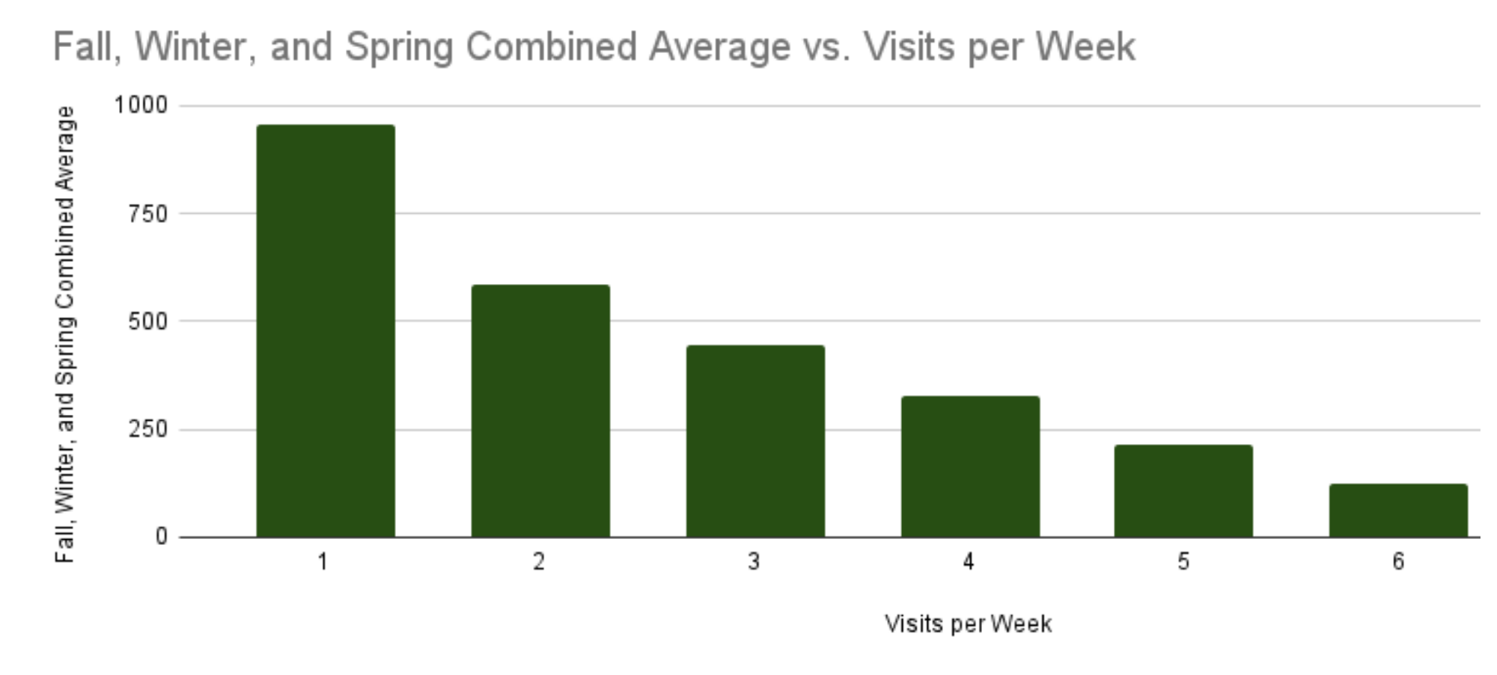
Weekly Usage

Our students are actively using the gym 1 to 5 times a week. For example, 444 students used the gym 3 times a week, and 215 students used the gym 5 times a week.

Monthly Usage
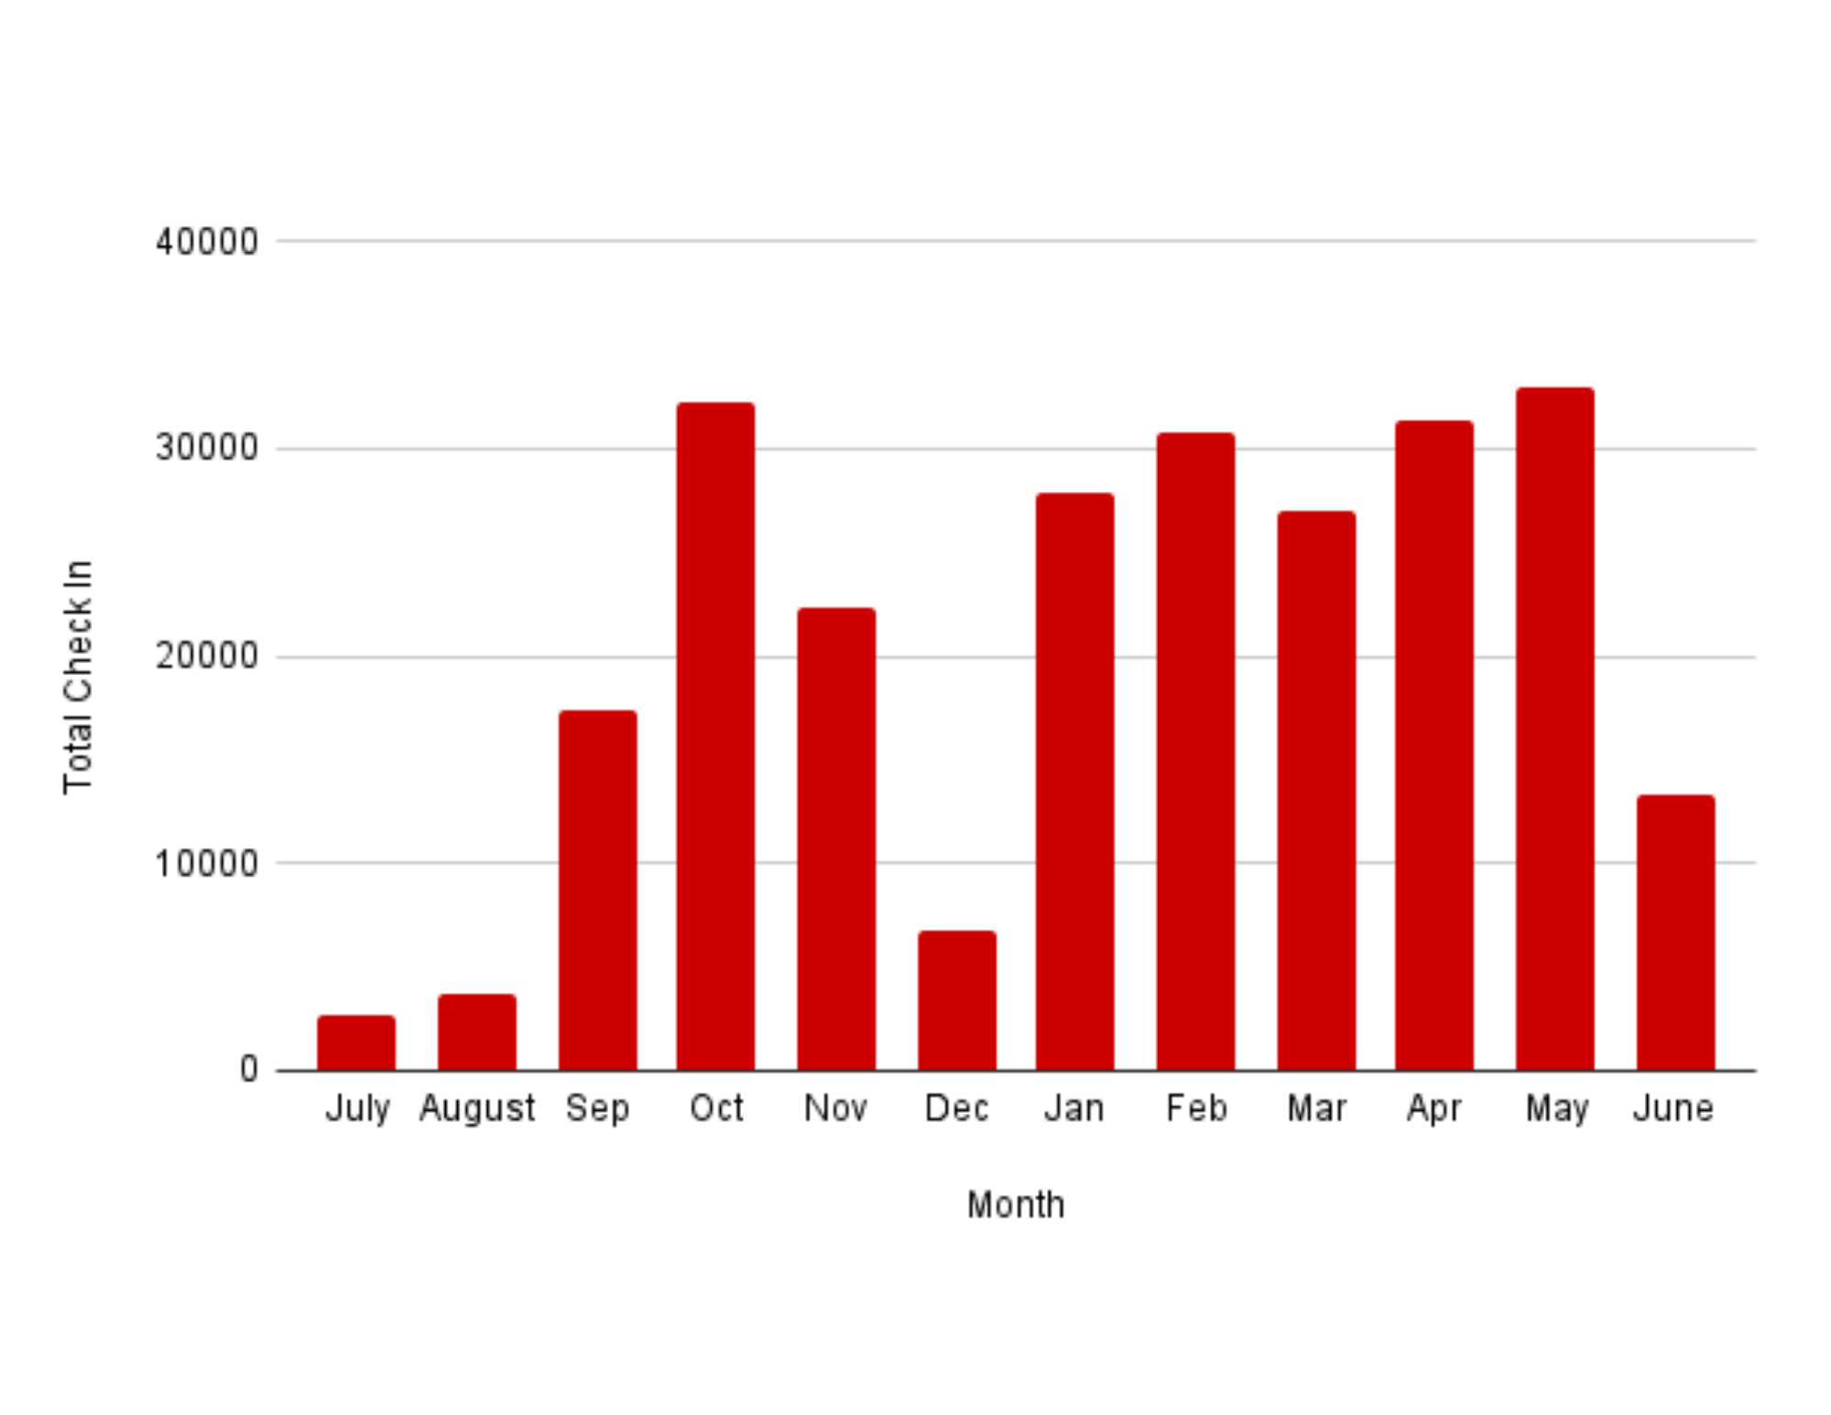

Guest Data
836 Guest Passes sold Jan. ‘23 - Jun. ‘23*, generating $18,670 in revenue.
*Guest Pass sales resumed Jan. ‘23

Visitor Data
1,042 Total visitors, the majority being prospective students and their families.

Facility Updates

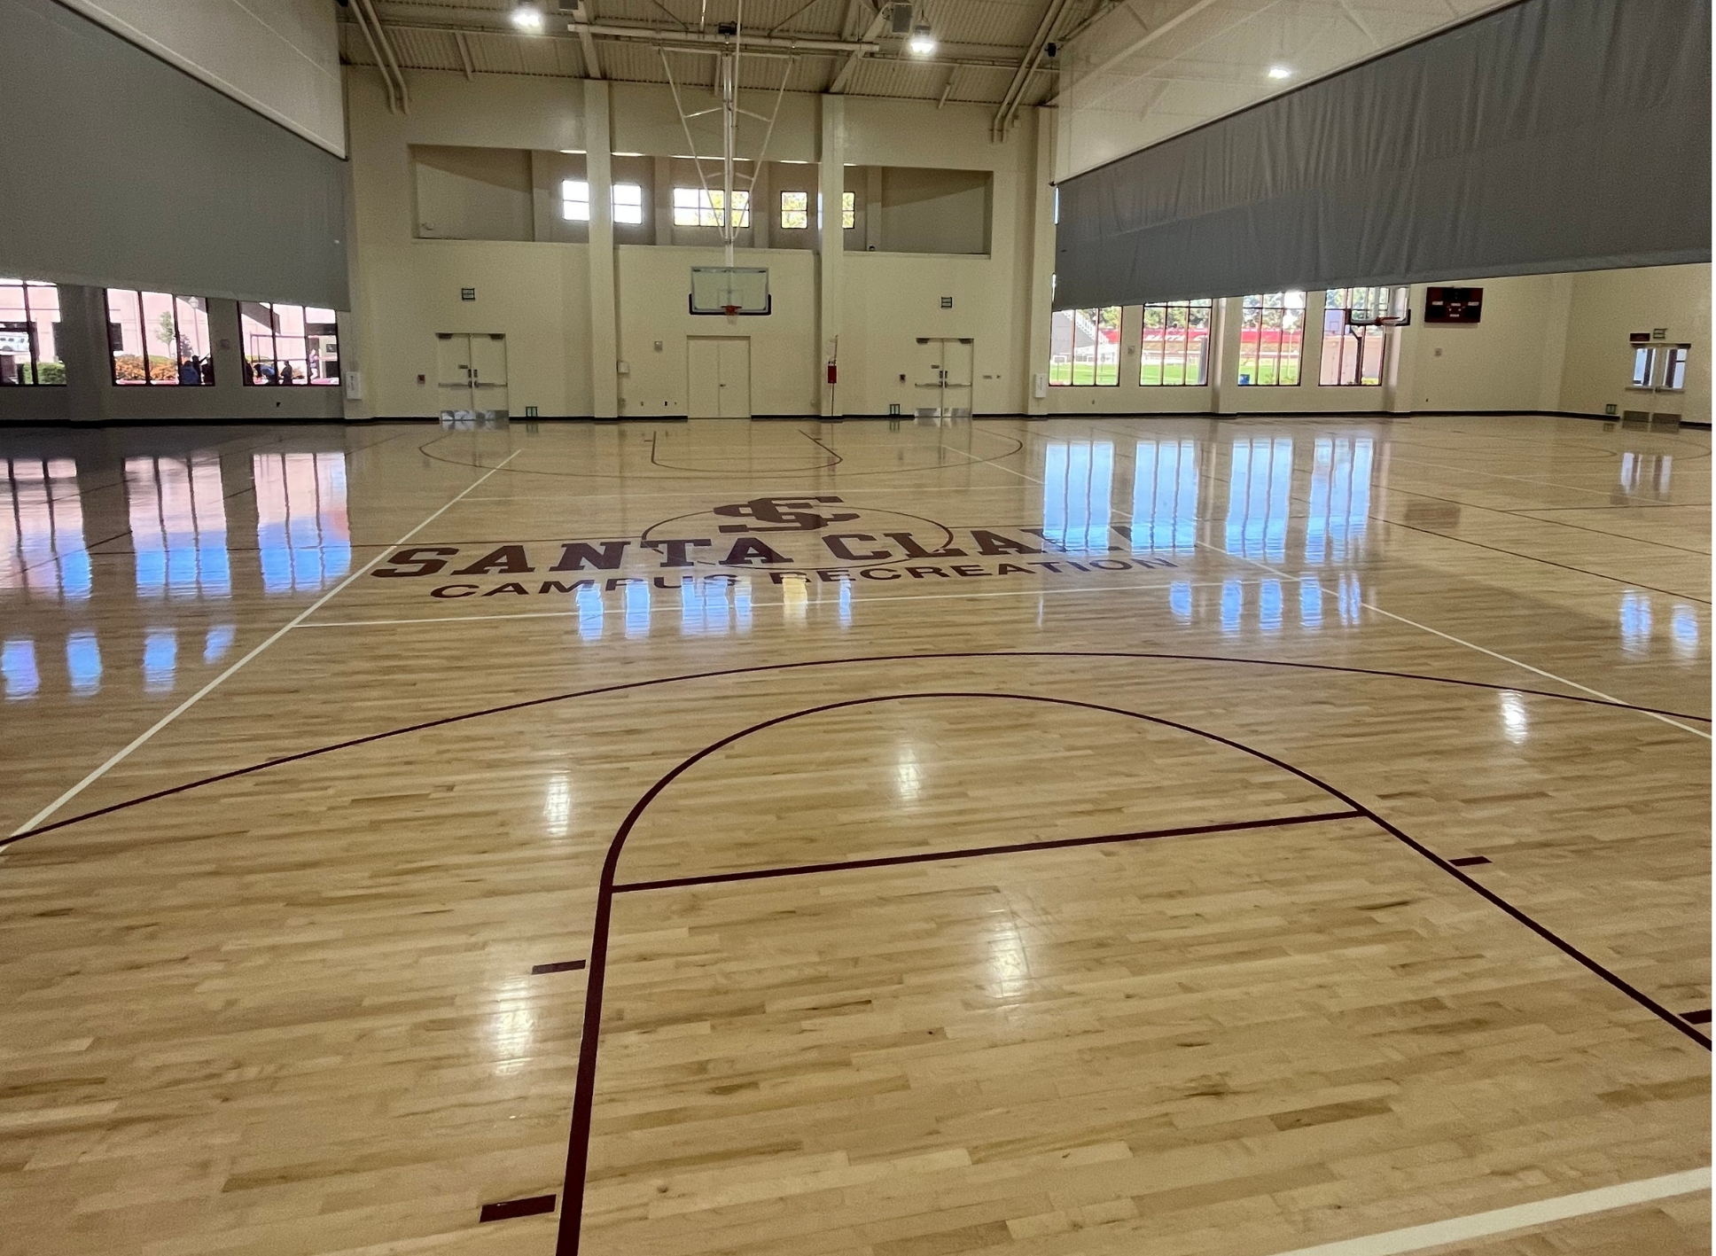
Court Floor Rebrand
$102k project to update the logo on court 2 and along baselines

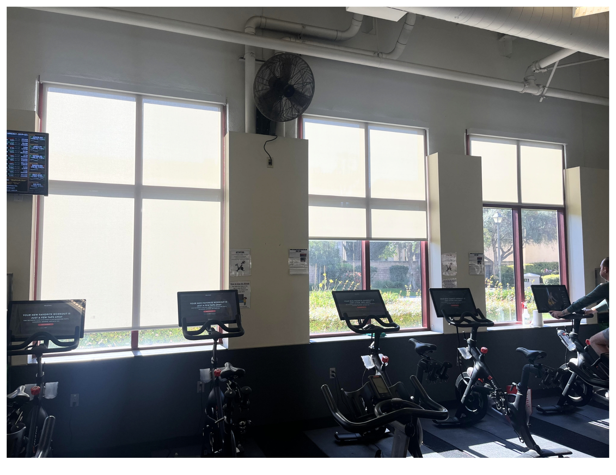

Weight Room Blinds
New shades block sunlight due to removal of old trees
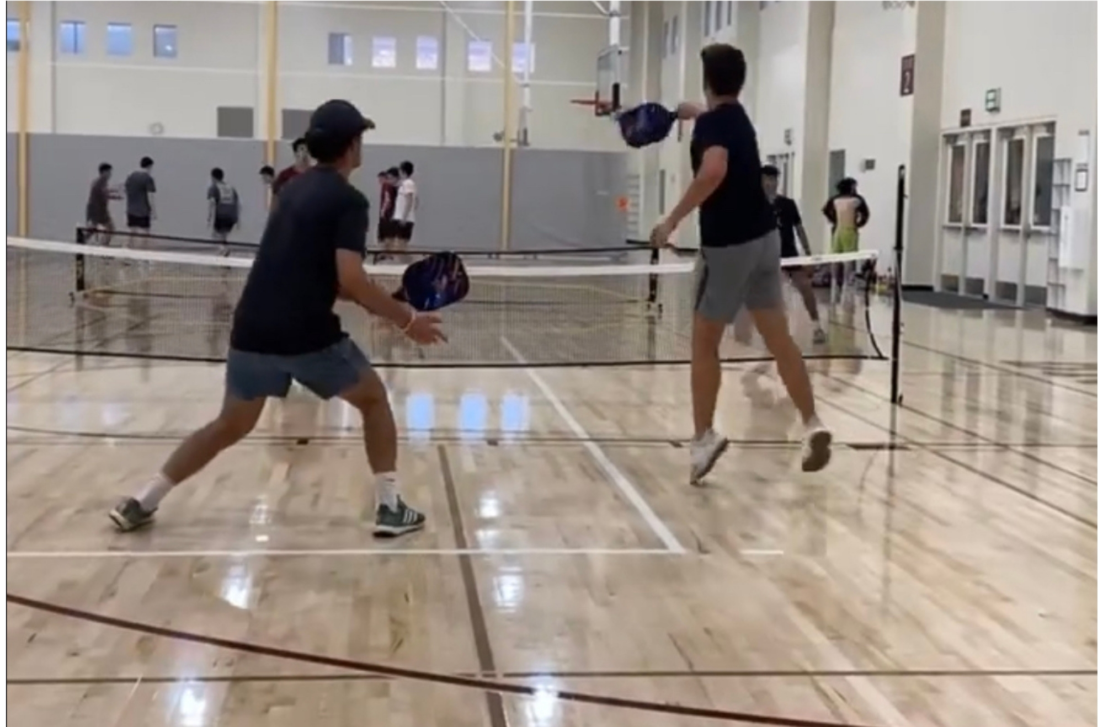

New Combo Pickleball Badminton Poles
Allowing for the addition of pickleball for Open Recreation and an Intramural Sport League

Club Sports
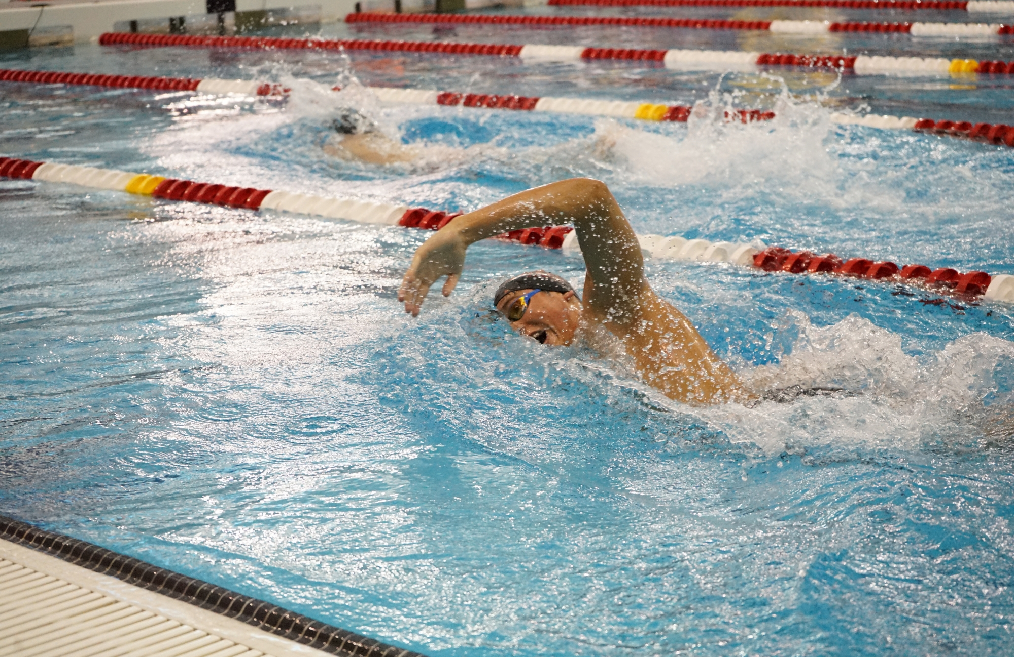

Club Sports returned for a full academic year of competitions

17 Programs
465 Total Participants
3.403 Average Cumulative GPA

6 new Club Sports approved to be added in the ‘23 - ‘24 season

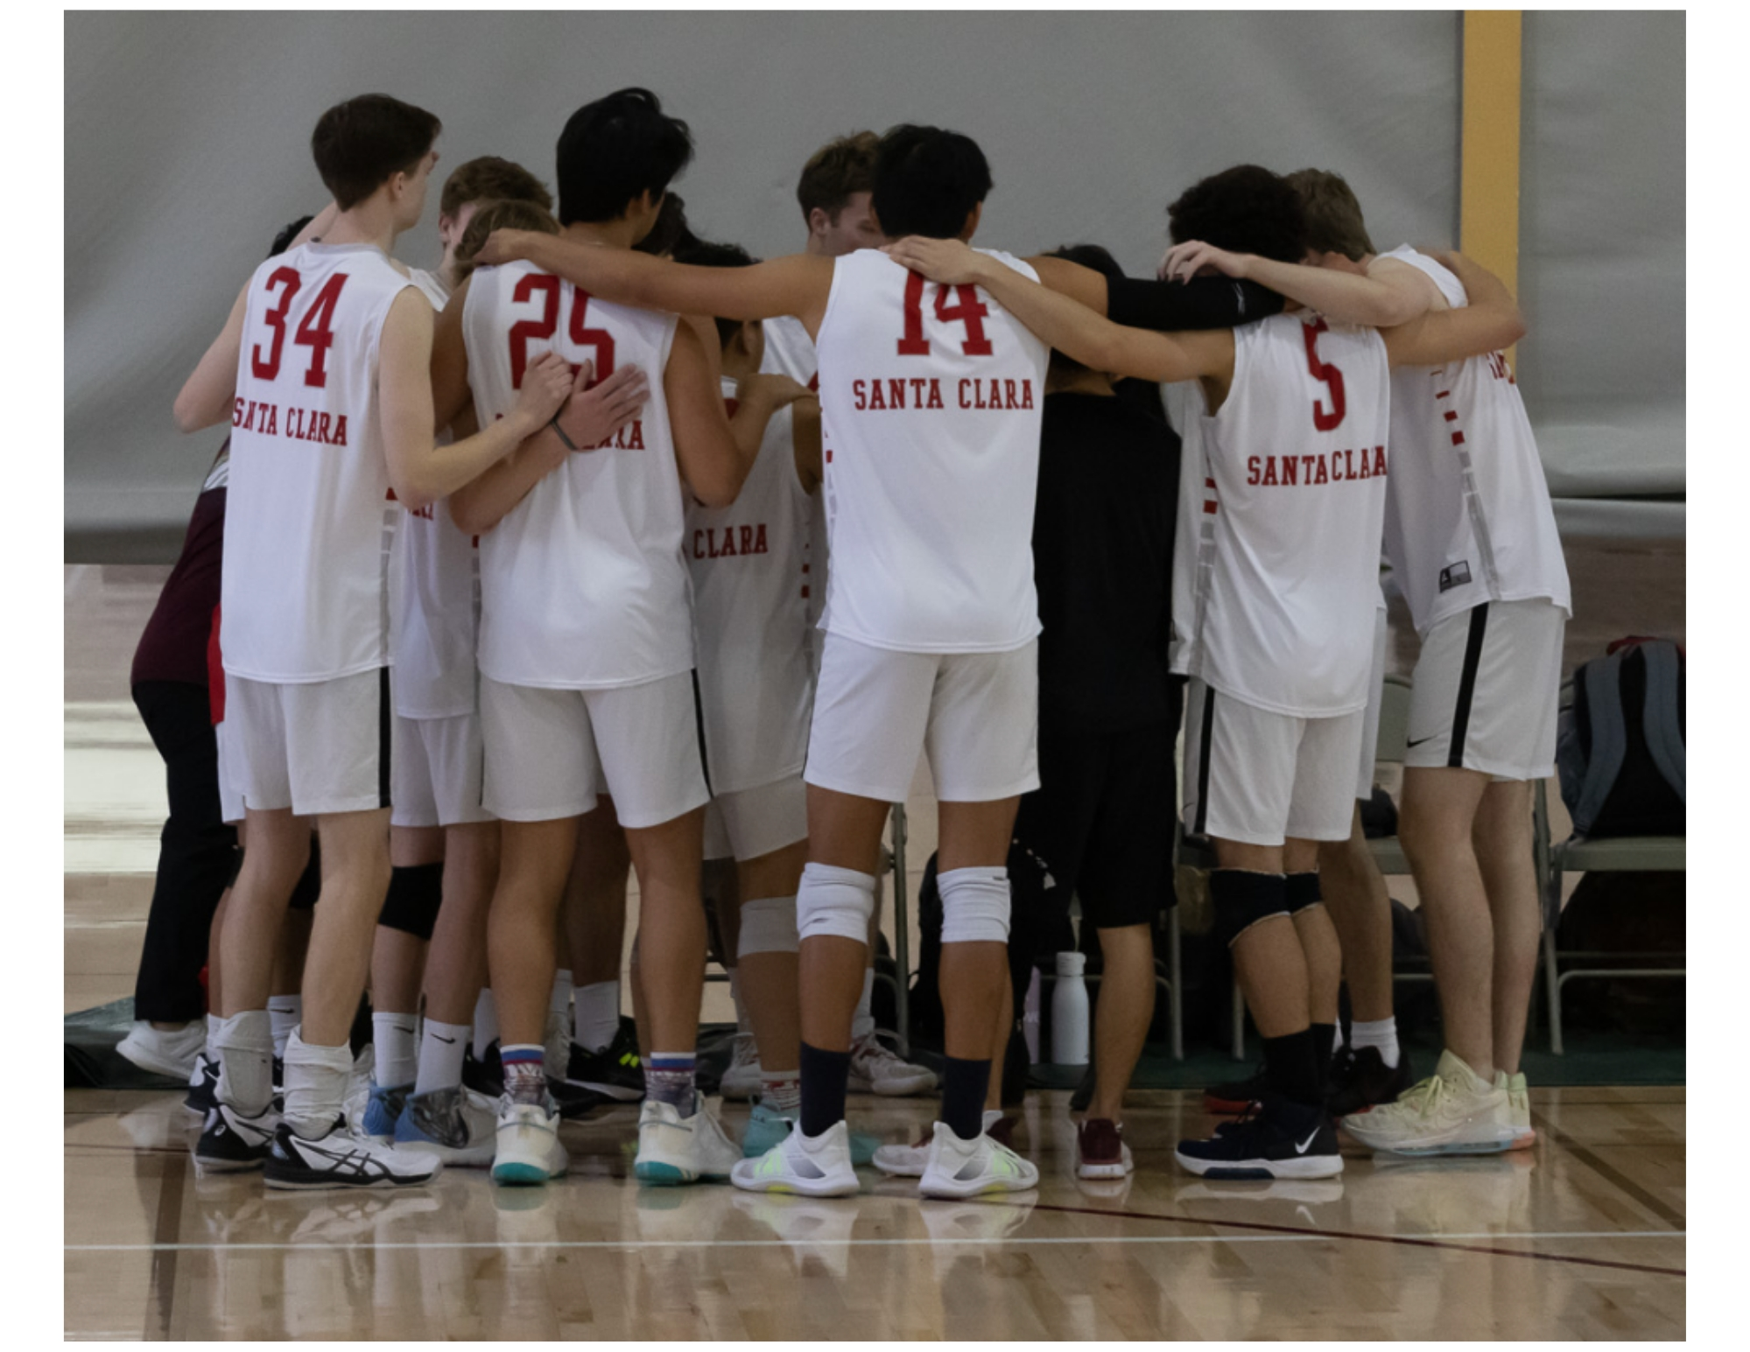
Notable Stats
- BOX had one Semi-finalist at Nationals who was named All-American
- MLT placed 1st in their Stanford Open Tournament
- MVB won 1st in their League & 5th at Nationals
- SWM had 7 swimmers qualify for & attend Nationals
- TRI had two top 20 performers at Nationals
- WCVB won 2nd in their League & 5th at Nationals

16 Club Sport Student Athletes received All-American, All-Conference, or All-League awards

Day of Giving
- MRG over $100k raised
- MLX over $45k raised
- Total for all Club Sports is $165,224 from 744 gifts
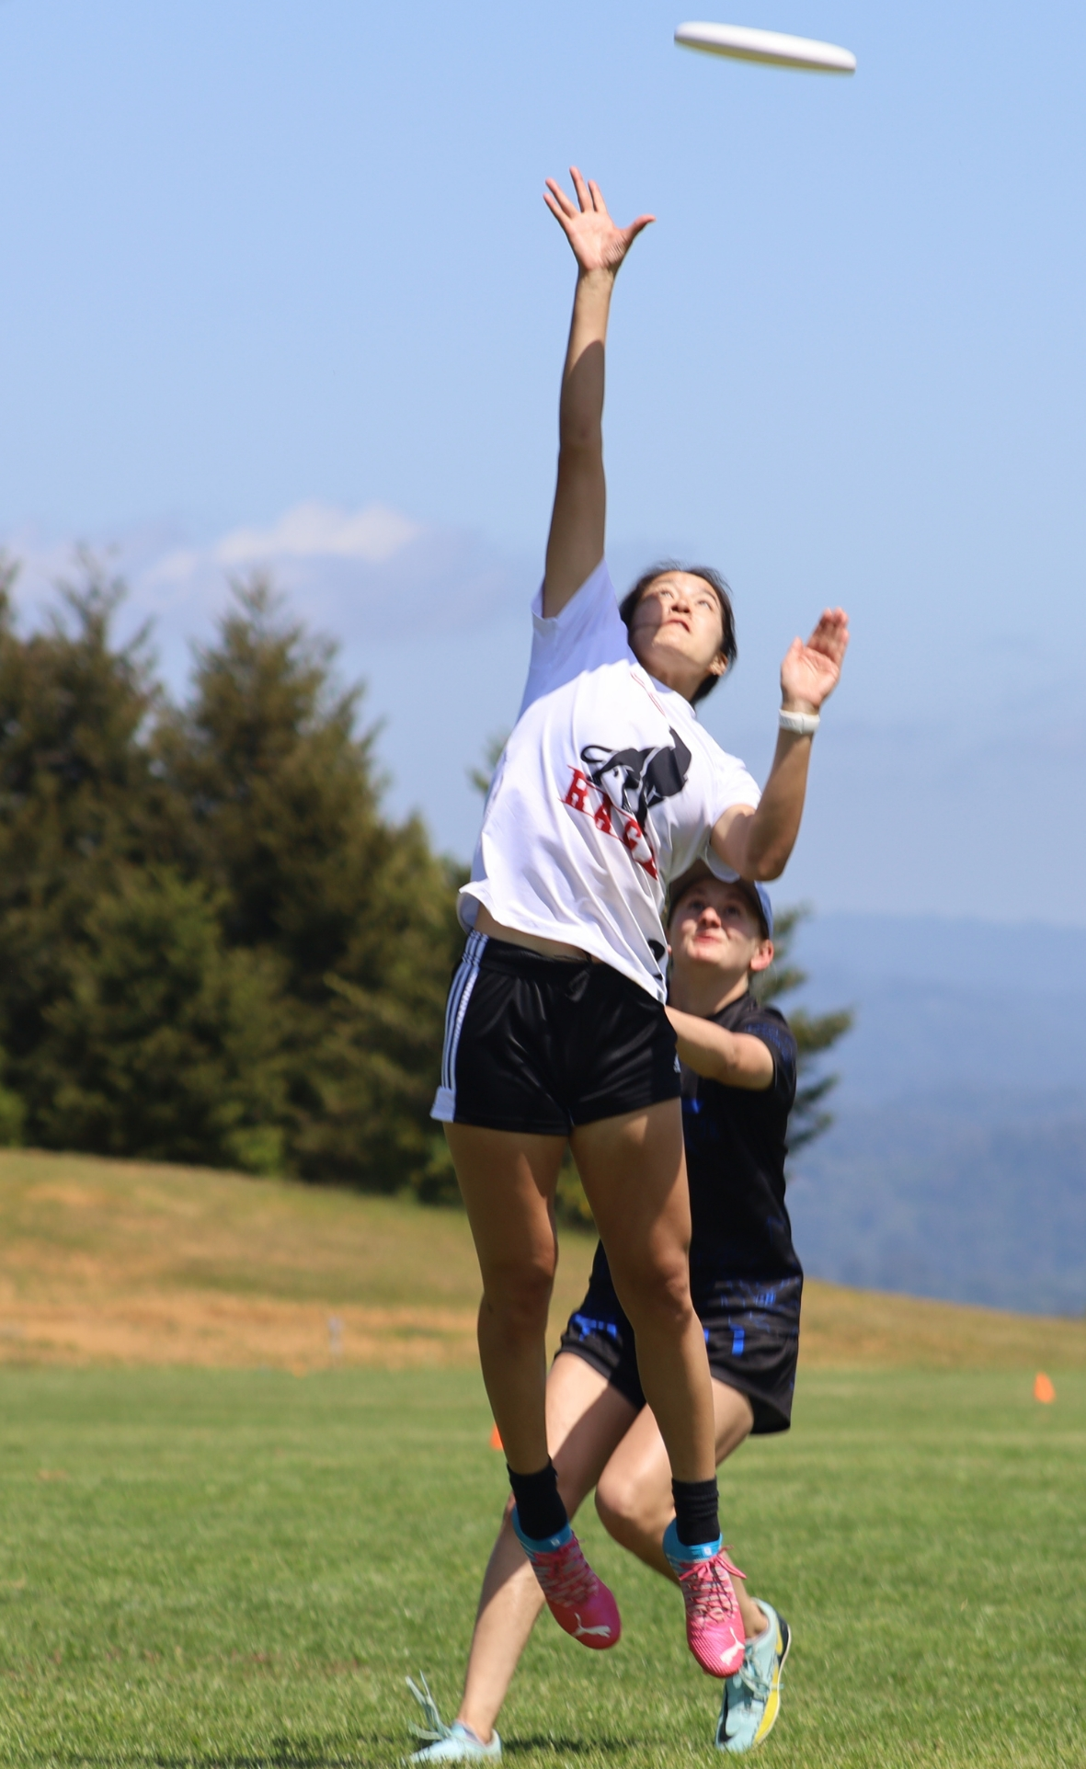

Intramural Sports

Participant Breakdown
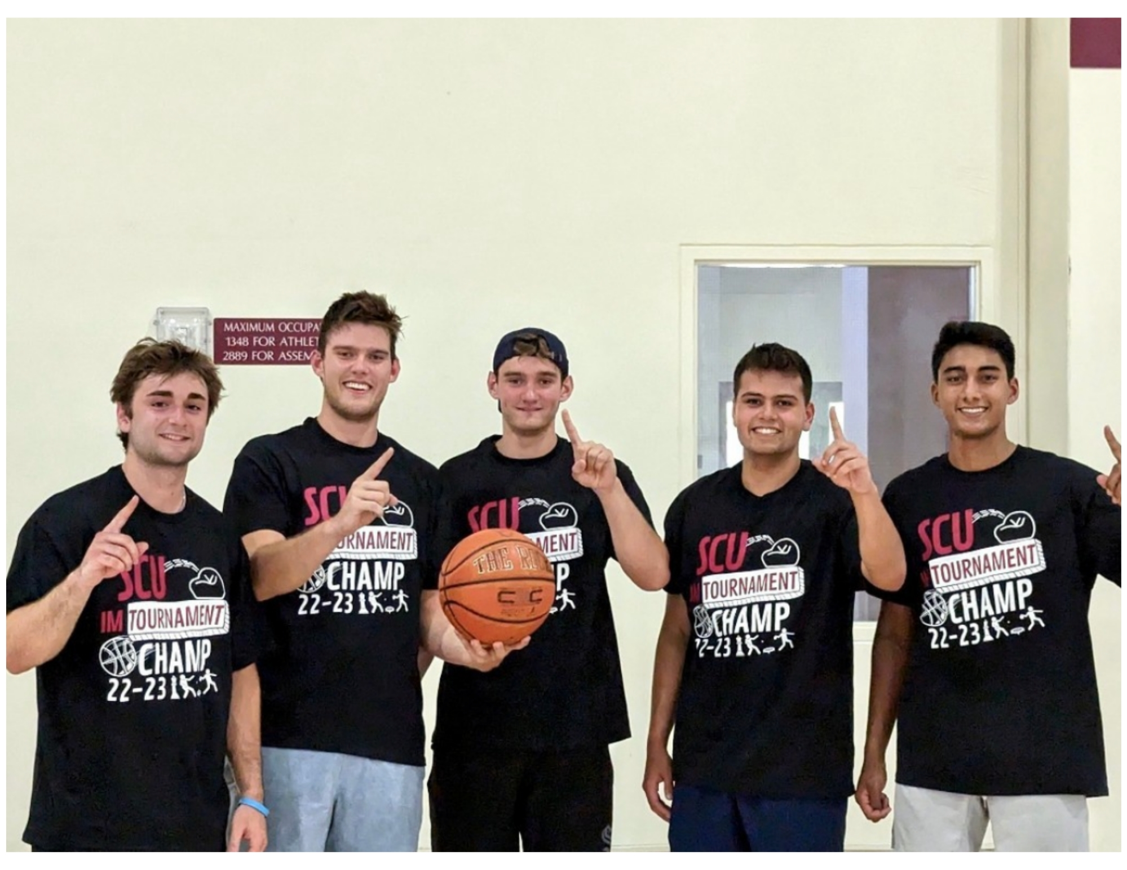
During the ‘22 - ‘23 academic year, all participant numbers shattered 3 records in 3 categories of participants
3,912 Total Participants
2,070 Unique Participants
108 Faculty/Staff Participants

IMs had to turn away 97 students who wanted to participate
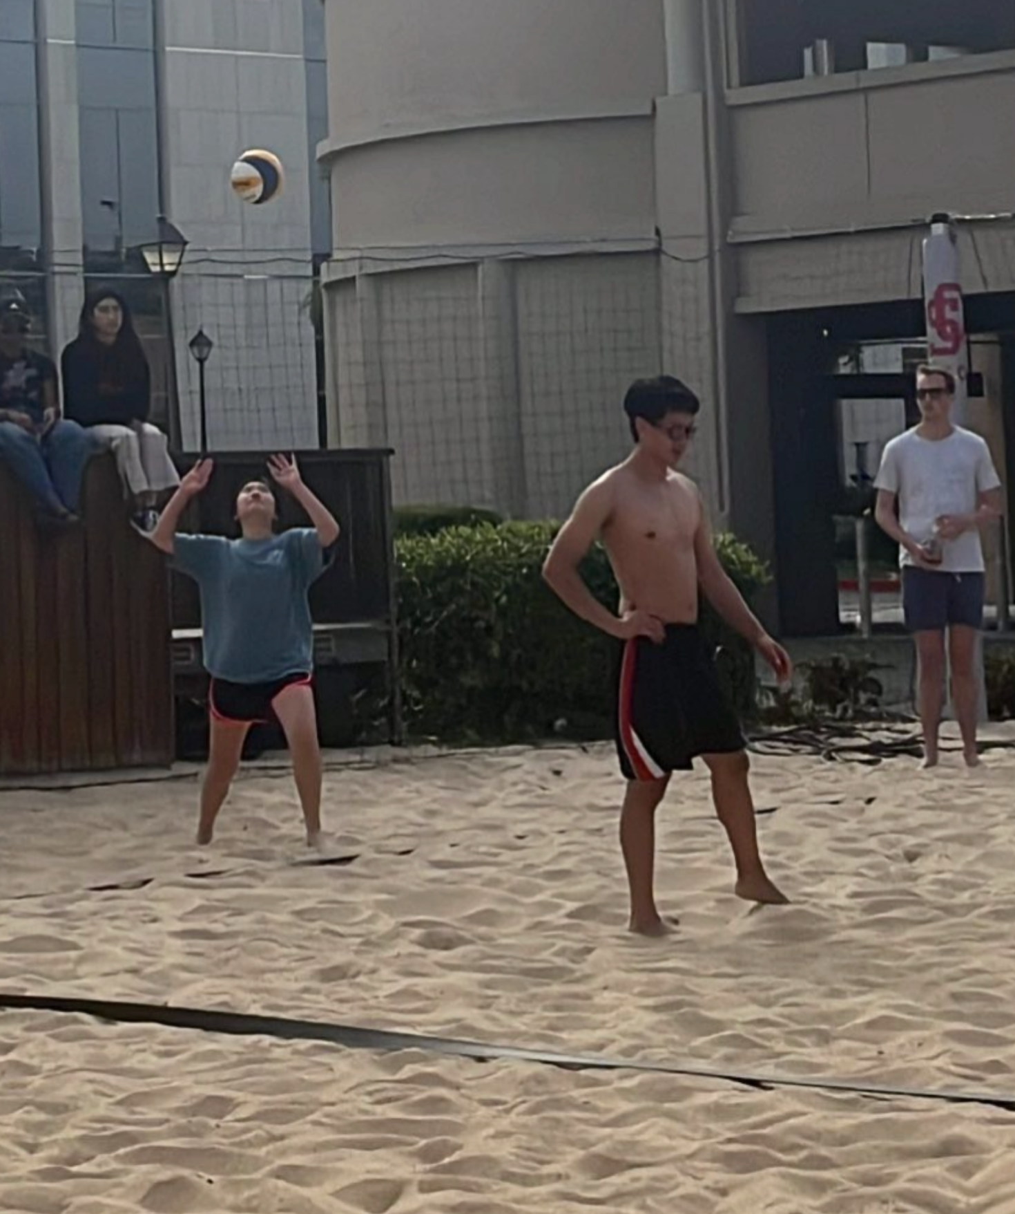

Most Popular Sports
- Soccer, Basketball, Beach Volleyball, and Pickleball were the sports with the highest participation

1 new sport
- Pickleball

3 new faculty/staff only leagues
- Basketball
- Softball
- Pickleball

Fitness Classes
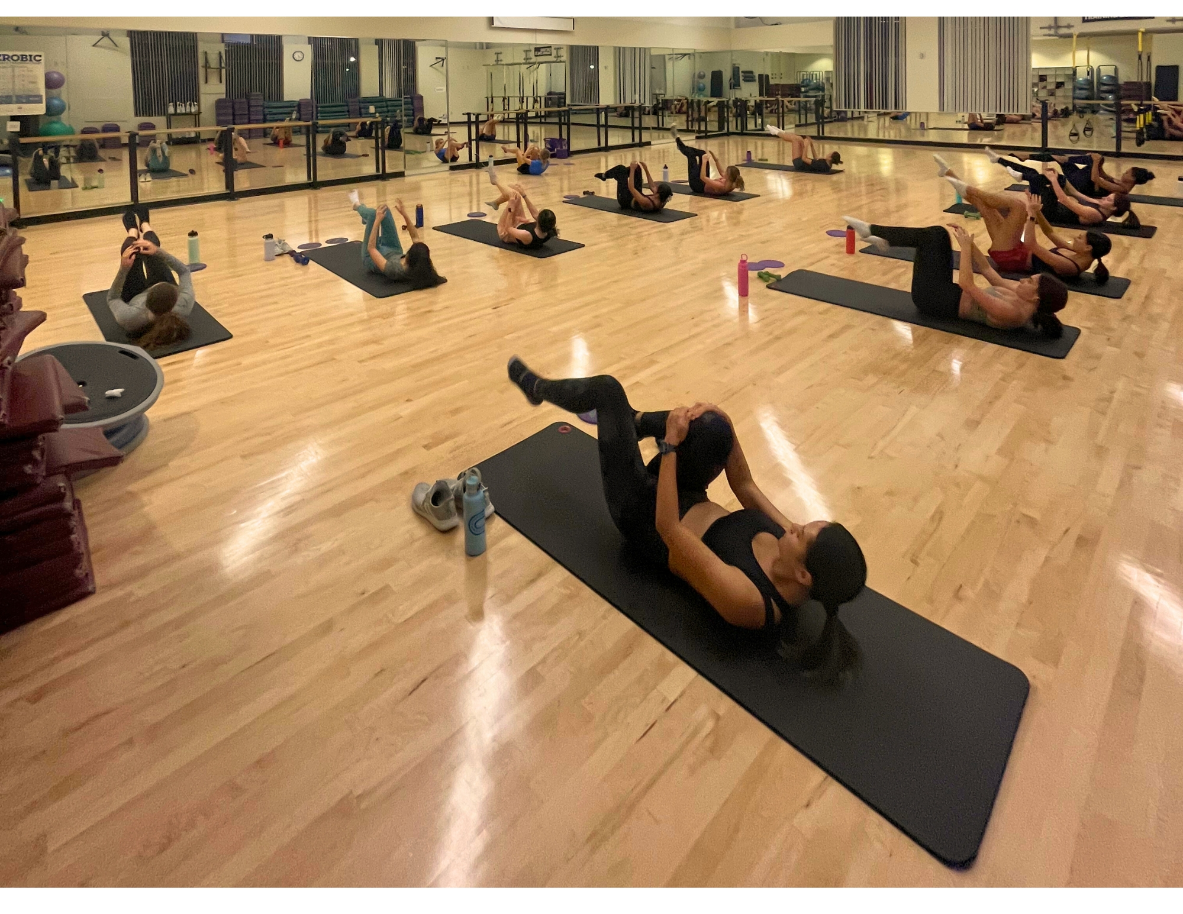

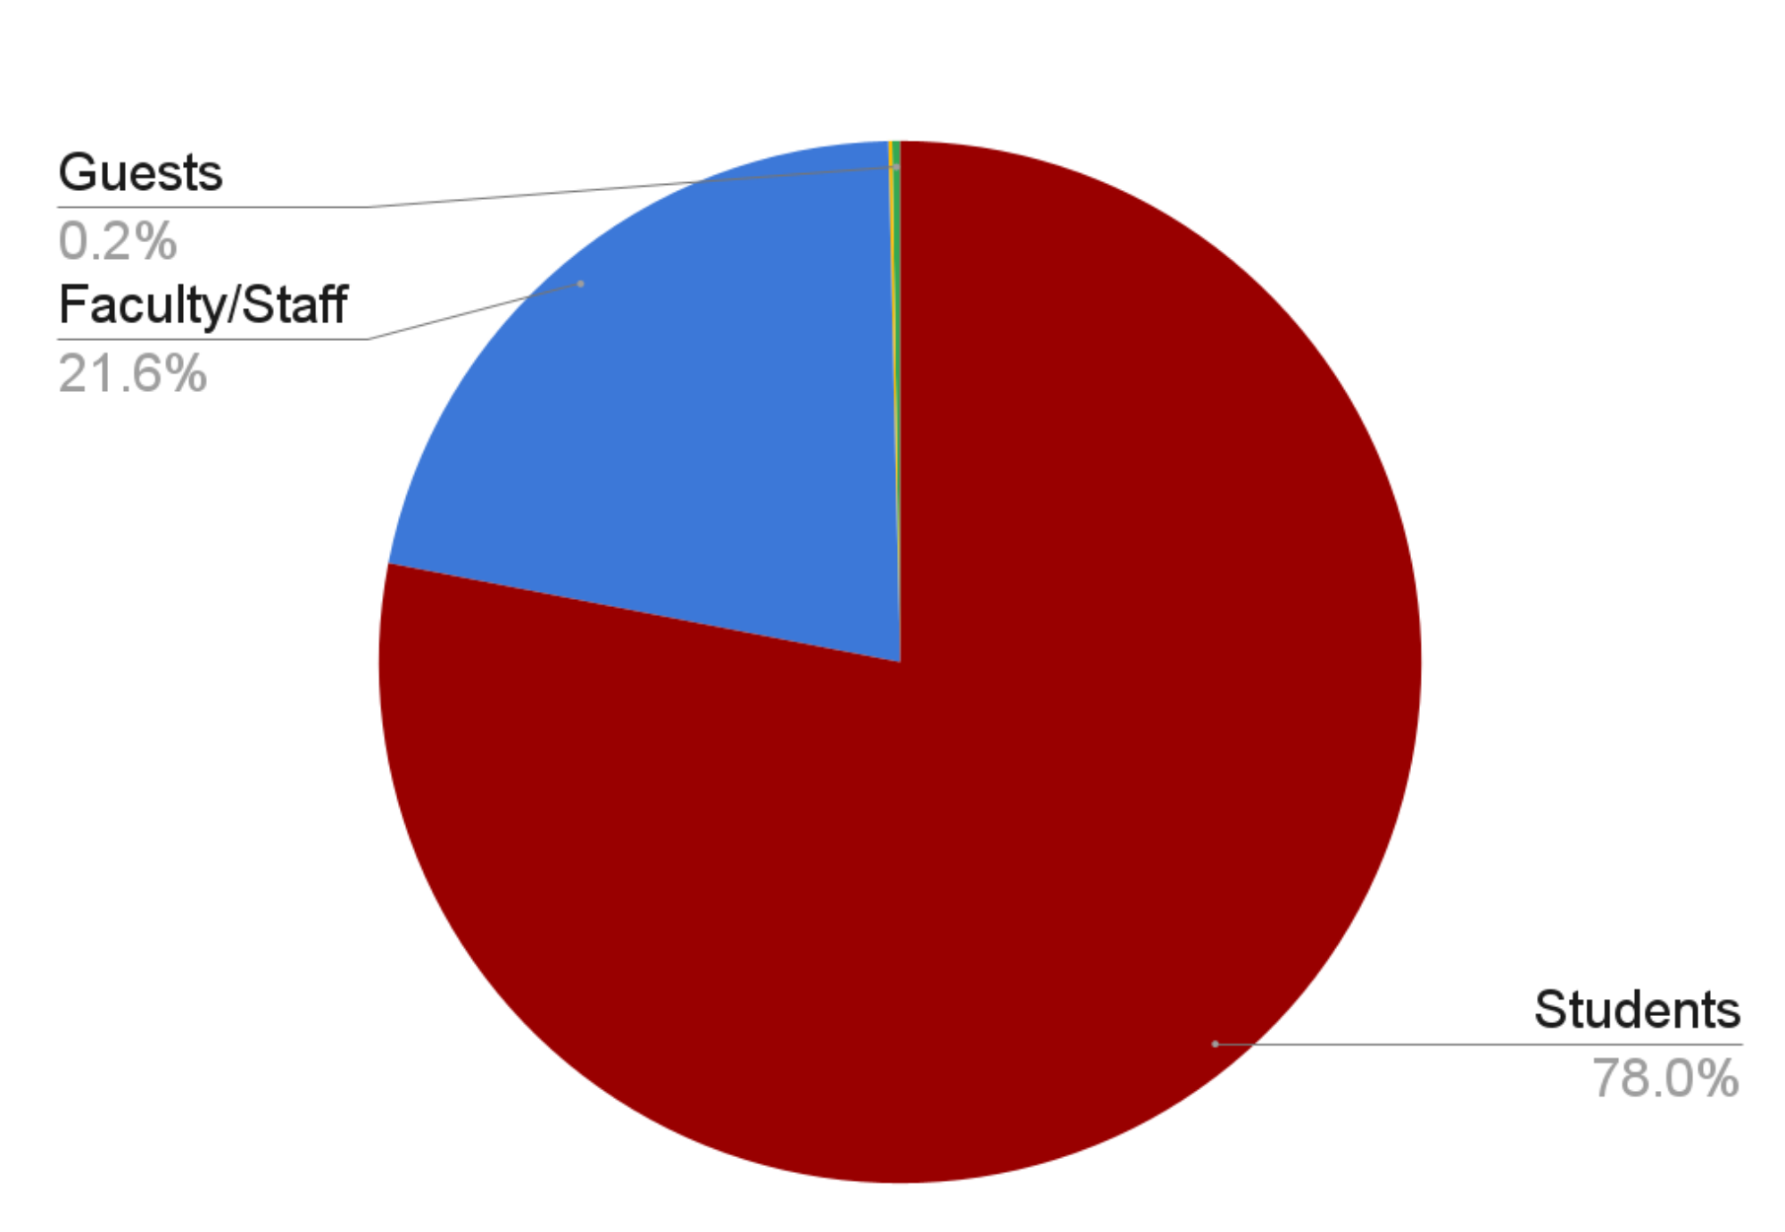

Participant Breakdown
48 Total Classes
426 Total Class Sessions
2,556 Total Class Participants

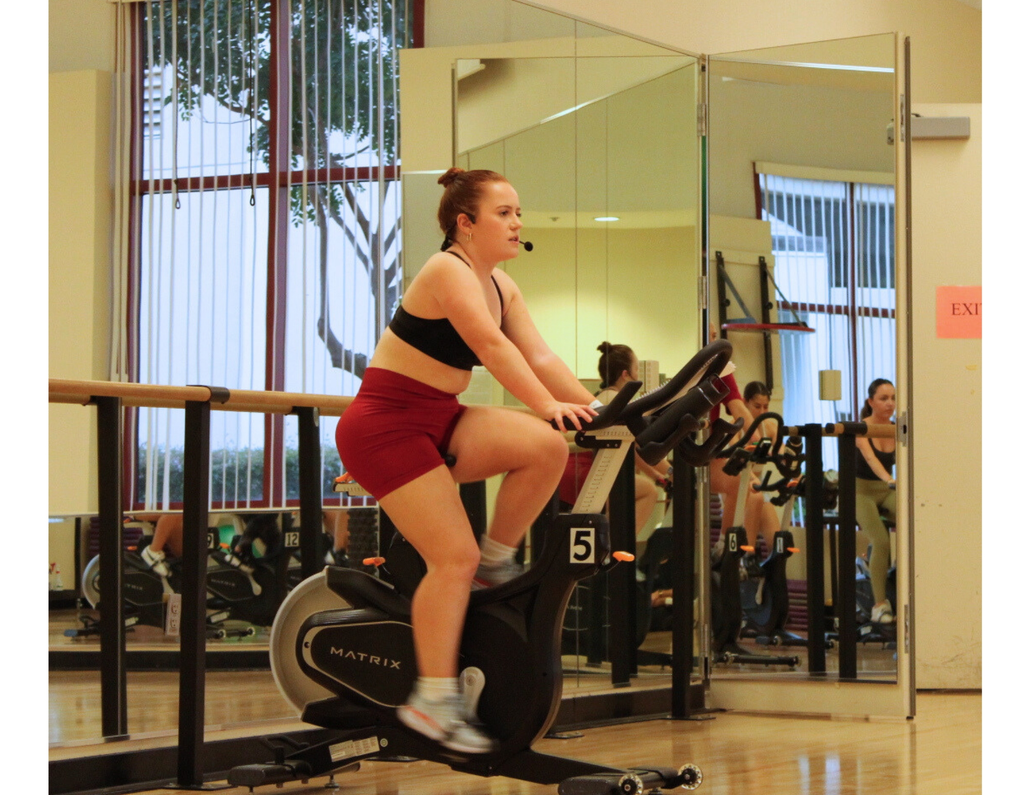

1,930 Students
534 Faculty/Staff
3 Alumni
6 Guests

Bronco Kids All Sports Camp
BKASC day camp made its first return since the Summer of 2019! We had 6 sessions running June 20 - August 5 (no session July 4 - 8).
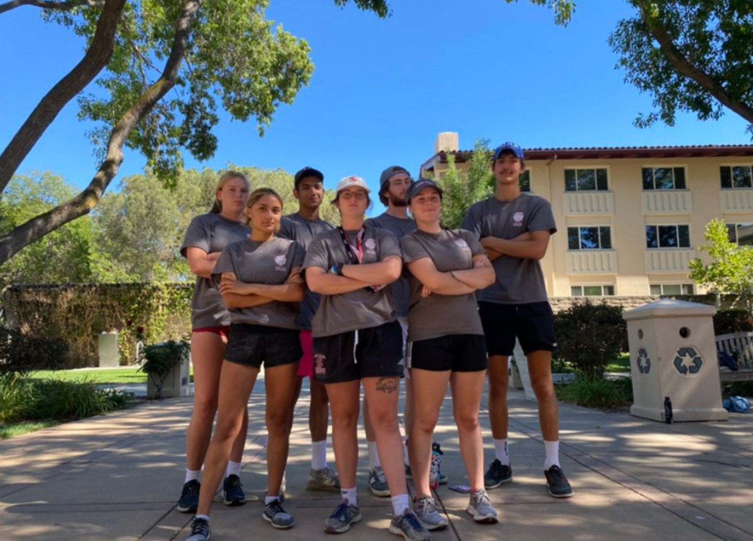
$180,285 Total Gross Registration Revenue
438 Total Campers
79 Counselors-In-Training
14 Student Employees

Student Employment
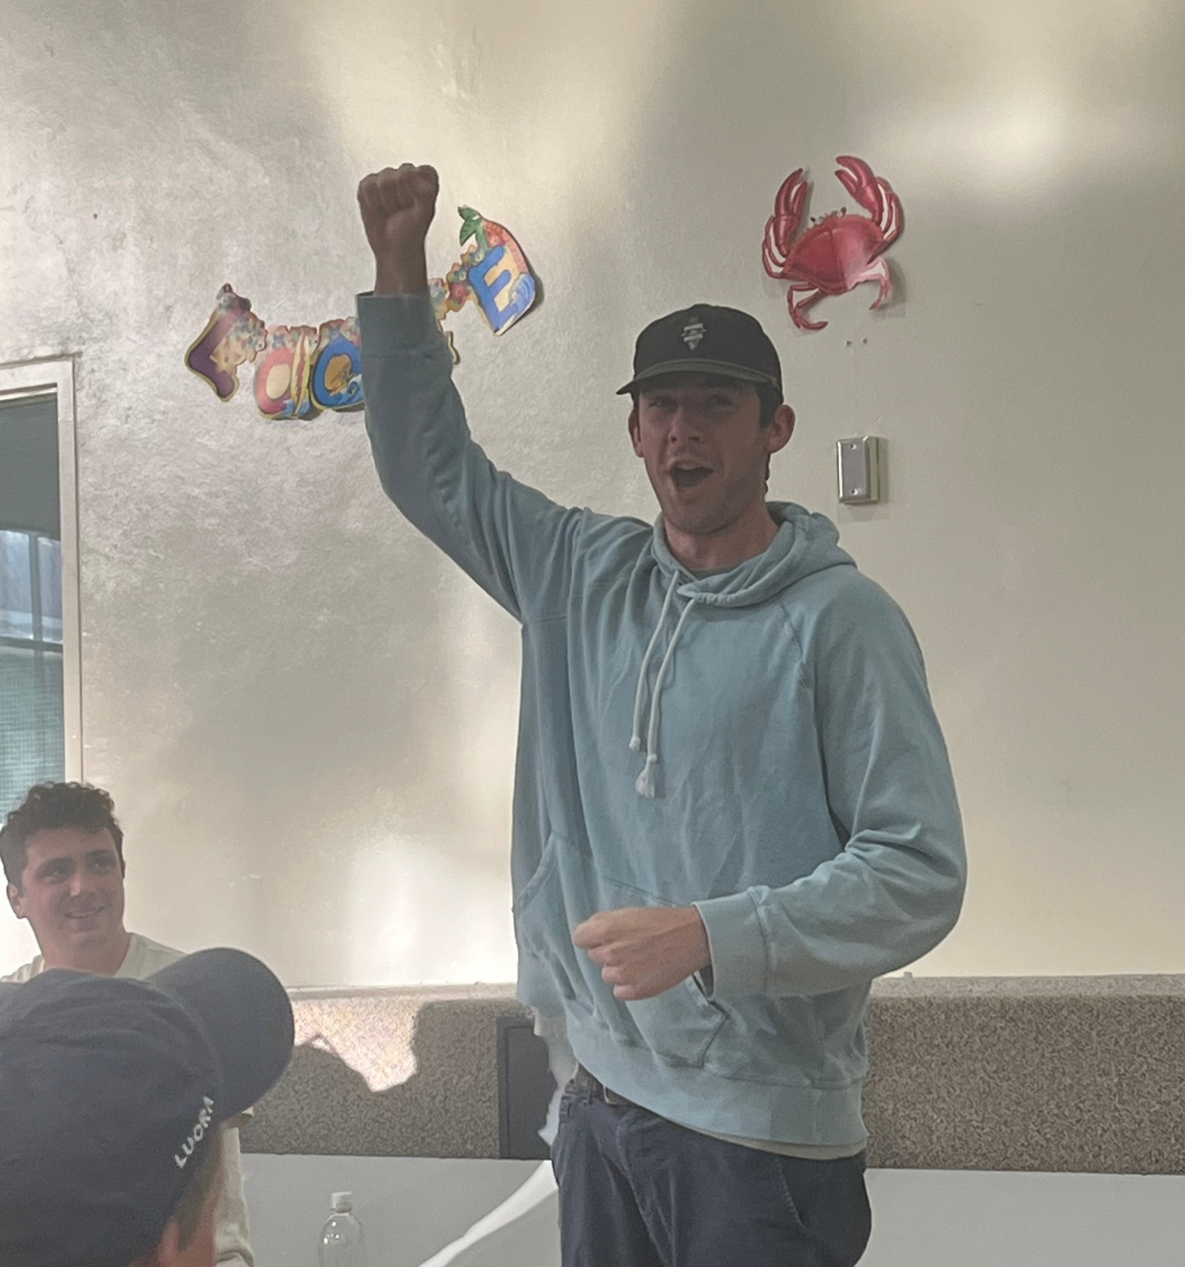
213 Total Student Employees, with 194 Unique Employees 11 students held 2 positions
84 new hires for the ‘22 - ‘23 academic year
8 Students promoted
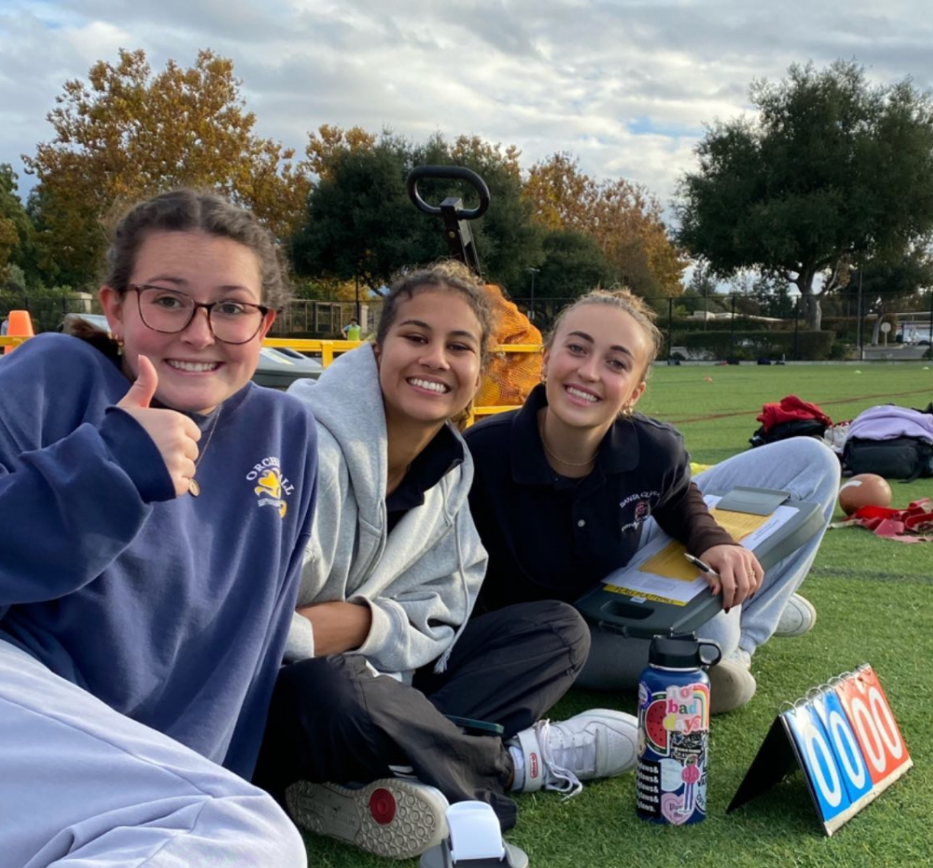

Facility Staff Positions | 104
Intramural Sports | 55
Bellomy Field Supervisors | 11
Student Fitness Instructors | 10
Bronco Kids All Sport Camp | 14
Student Coordinators | 19

