Campus Recreation Annual Report

2023-2024

Malley Center Check-In Data
265,516 Total Check-ins July ‘23 - June ‘24
6.89% Increase in Check-ins from July ‘22 - June ‘23

Daily Usage
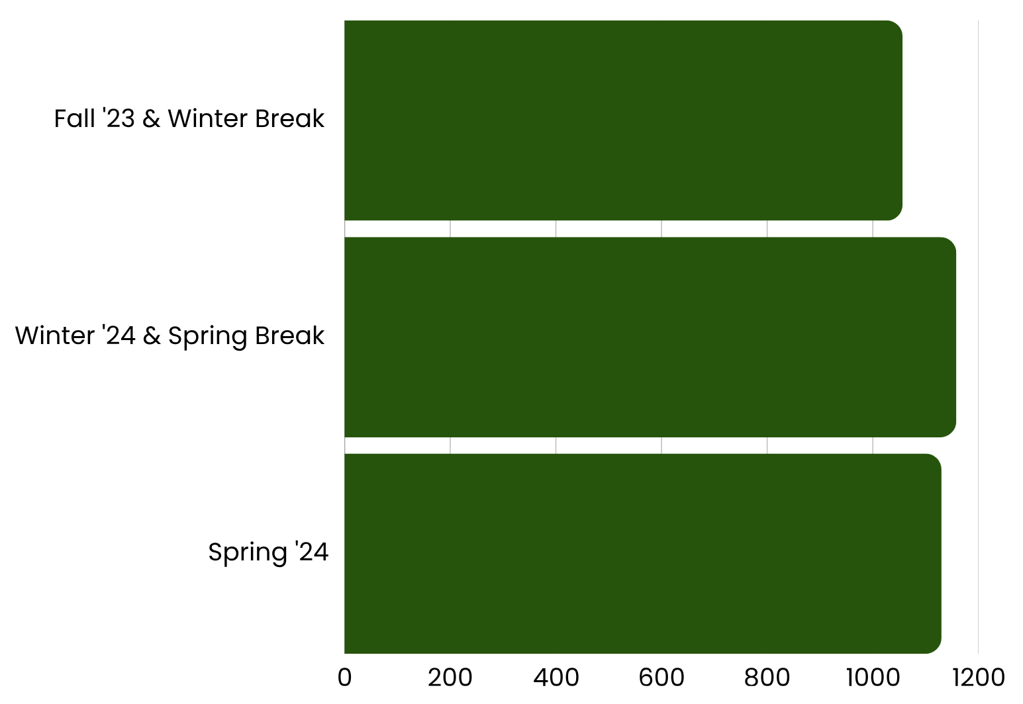
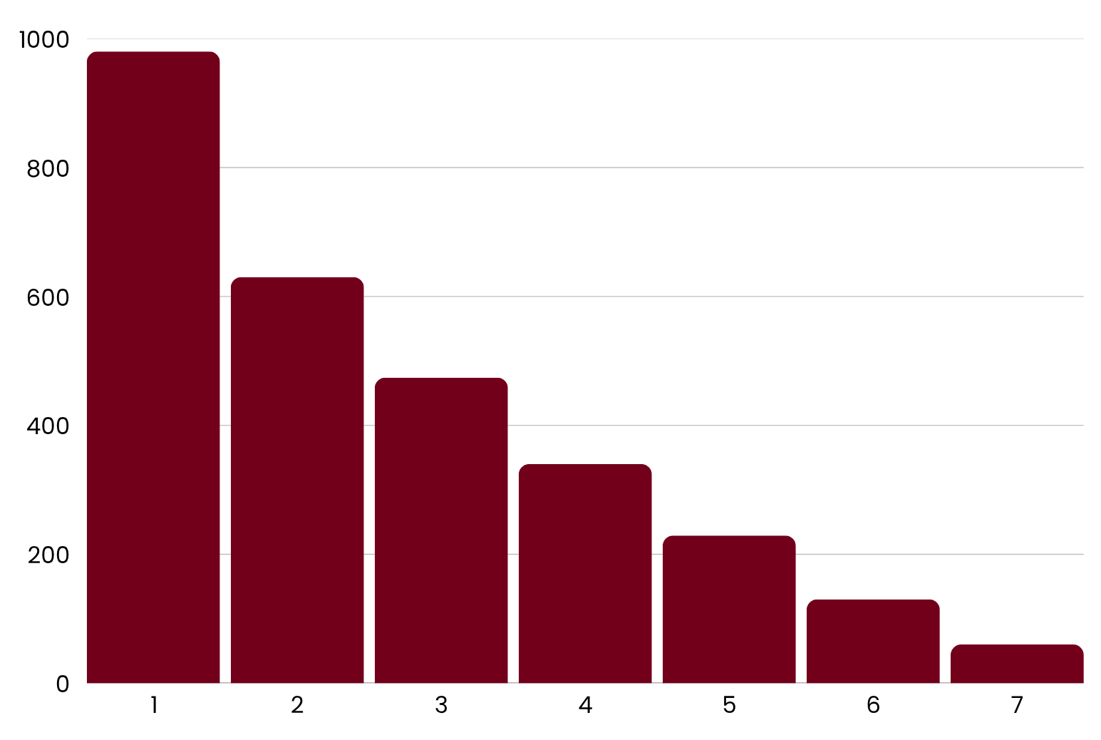

Weekly Usage

The weekly usage of the gym averages 1 to 6 times a week. For example, 630 people used the gym 2 times a week, and 130 people used the gym 6 times a week

Monthly Usage

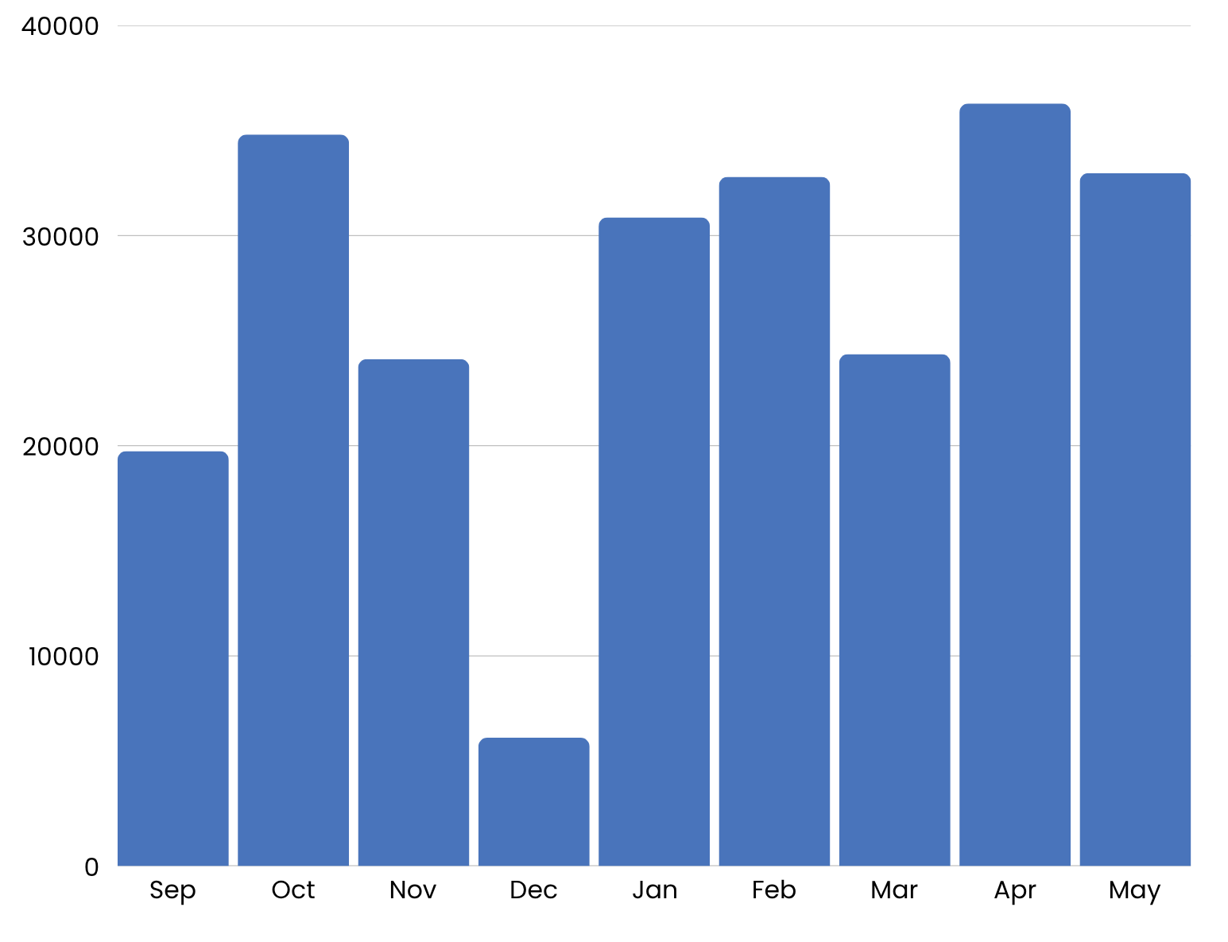

Guest Data
There were a total of 1,797 guest passes sold between July 1, 2023 and June 30, 2024, generating $47,640 in revenue.

Visitor Data
1,098 total visitors, the majority of them being prospective students and their families.

Fun Facts
In April ‘24, we had a monthly check-in total of 36,282 and the most check-ins in one day was 1,904 on April 2nd!

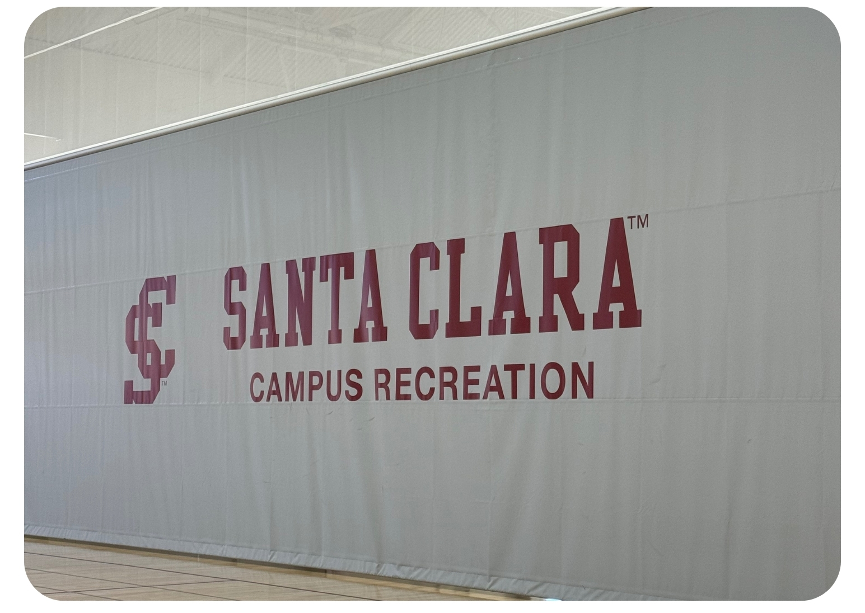
Facility Updates

Divider Curtains Replaced
The courts were transformed with newly designed divider curtains with logos facing Courts 1 and 3

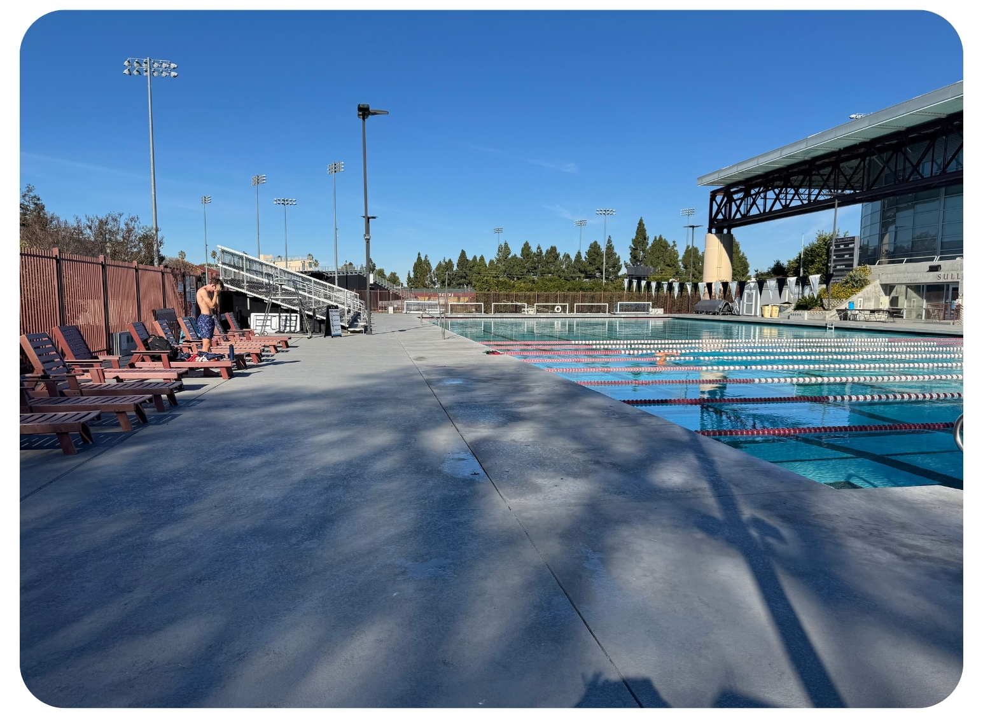

Pool Deck Repairs
Summer ‘23, the pool deck was sandblasted and a new surface adhered down.

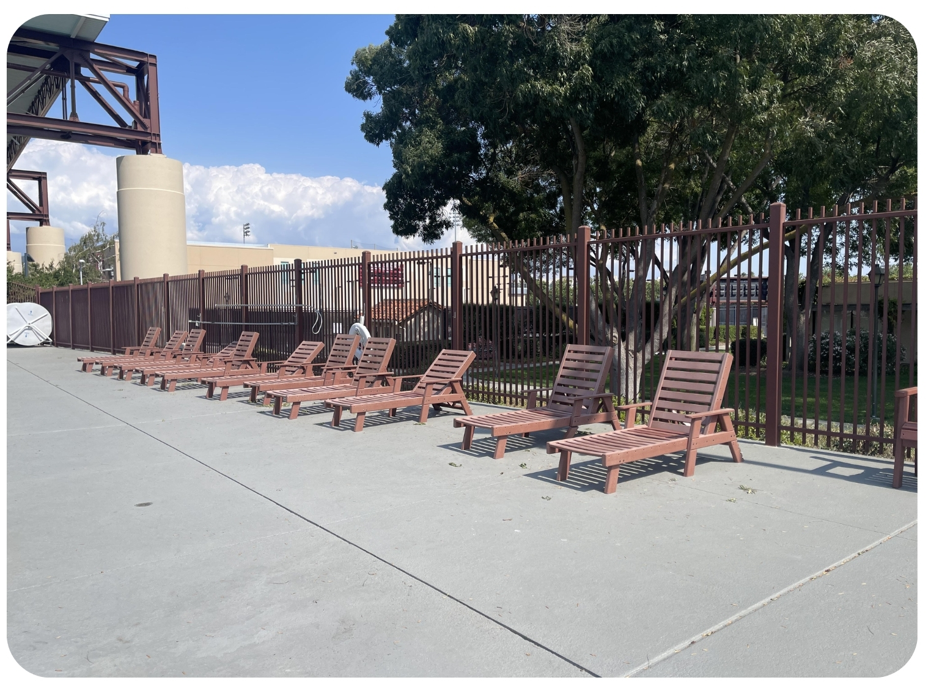

Pool Lounge Chairs
Five additional lounge chairs were ordered for student users. We now have 25.

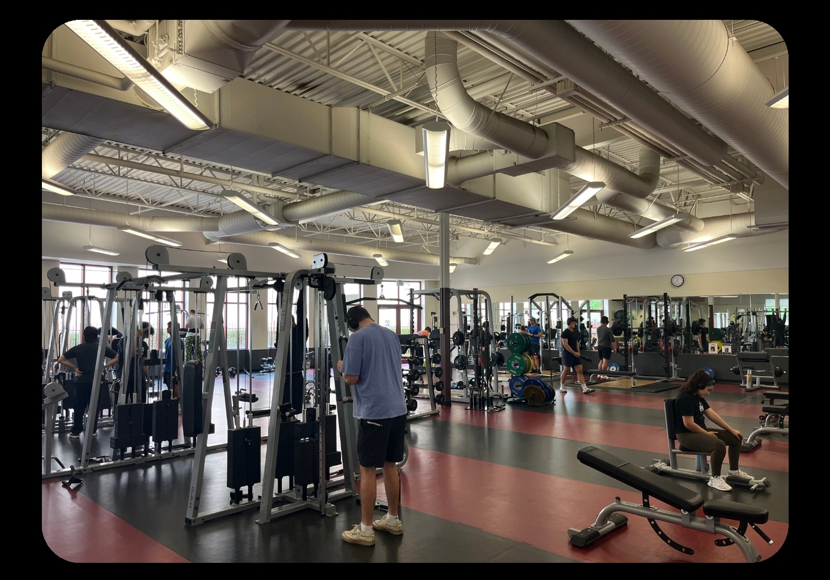

Weight Room Changes
The removal of 14 pieces of cardio and 3 plate loaded pieces made it possible to add more space for strength training and the increased number of users.

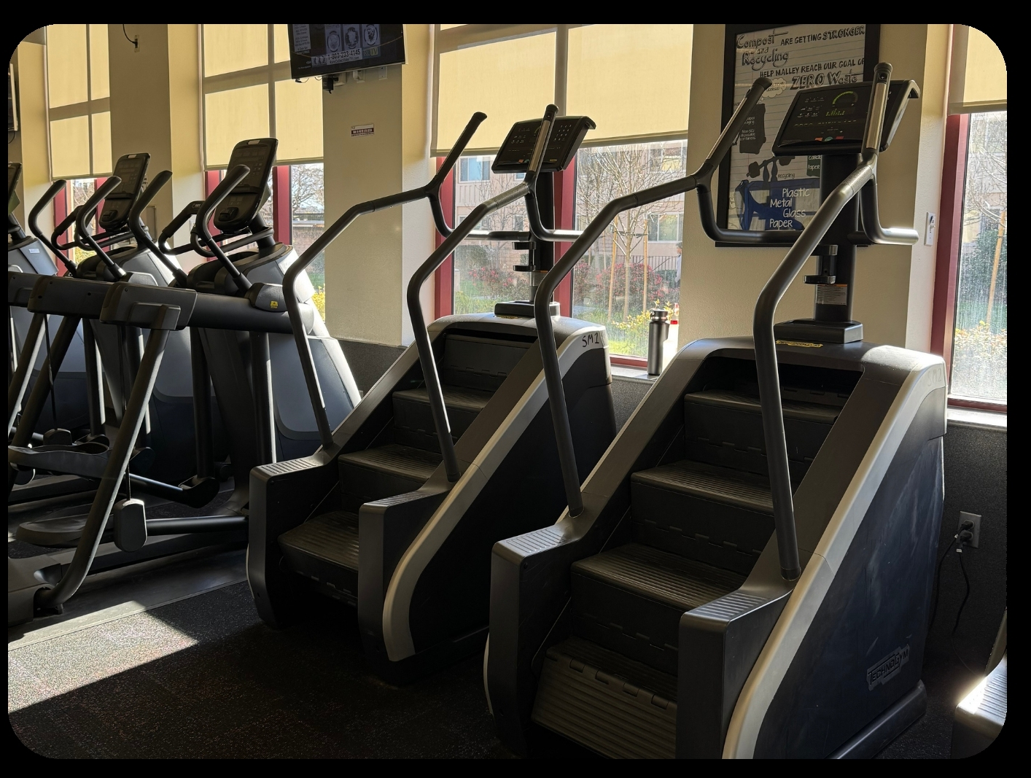

Weight Room Additions
We added one treadmill and one stepmill to the weight room

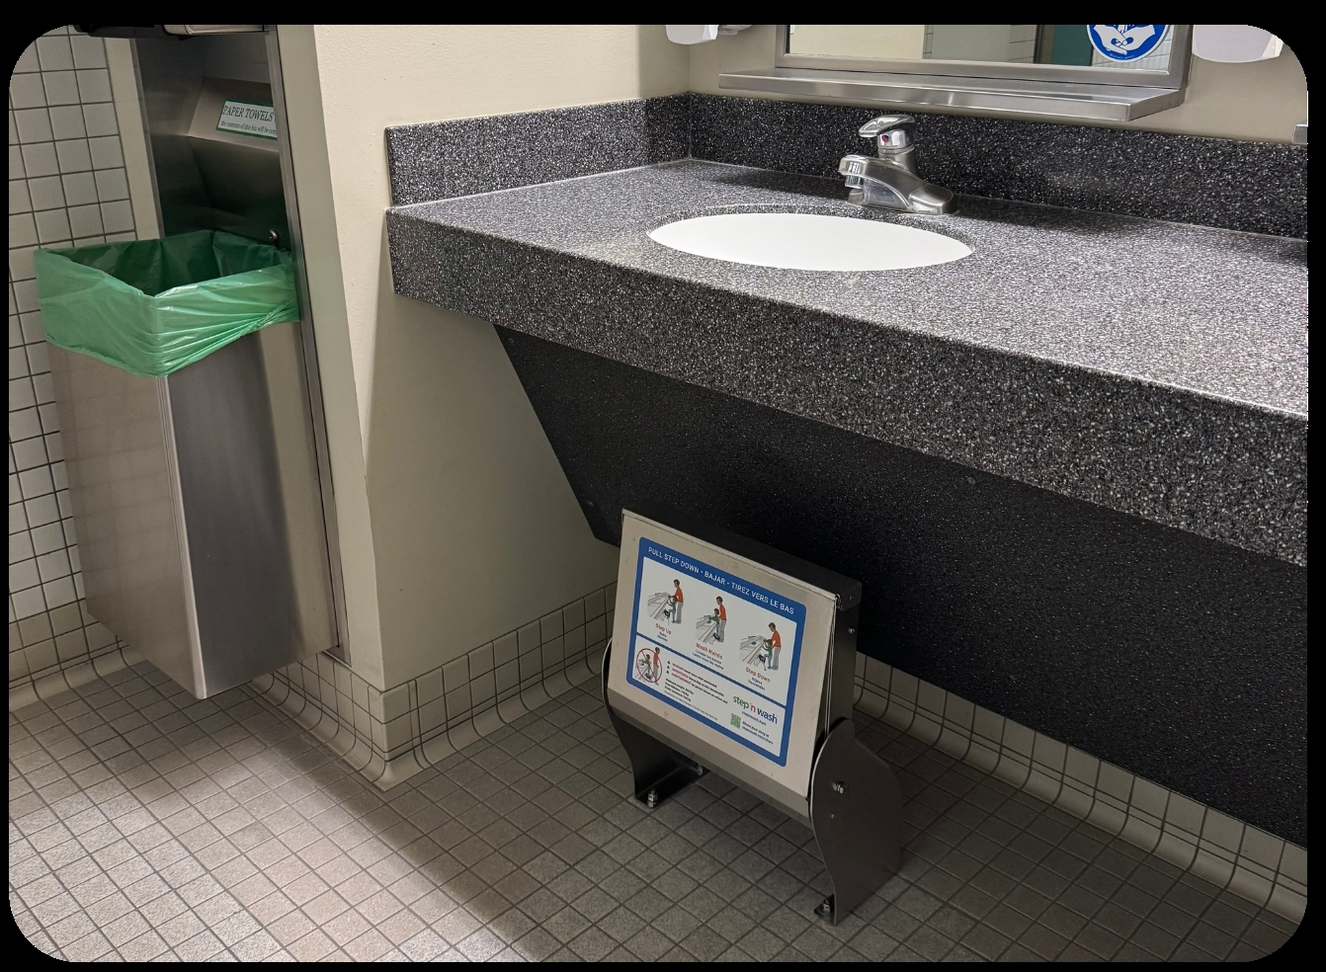

New Stool Steps in Locker Rooms
We added steps in the locker rooms at the sinks to make the area more accessible for our guests and patrons.

Club Sports

Club Sports introduced six new Club Sport Programs starting Fall 2023, increasing participation by 55.7% from the ‘22 - ‘23 academic year with the additional teams.

New Club Sport Teams

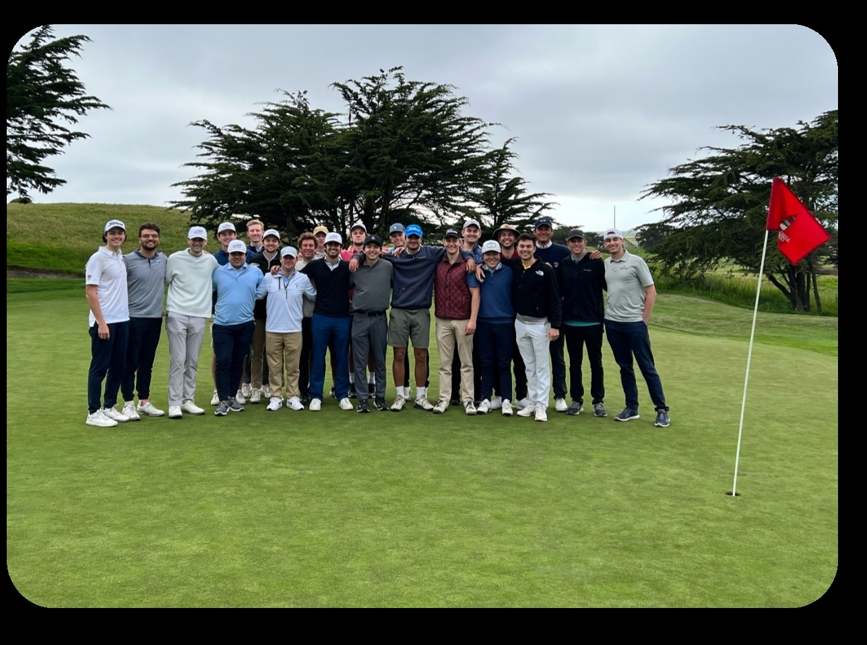
Bowling Club Golf
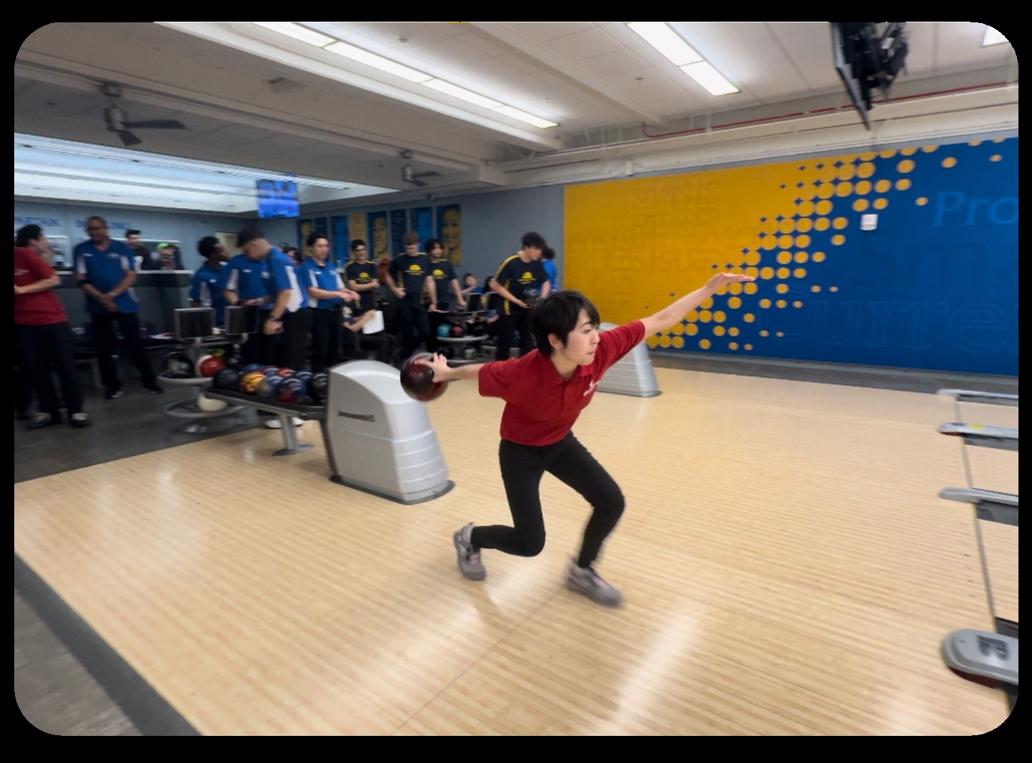

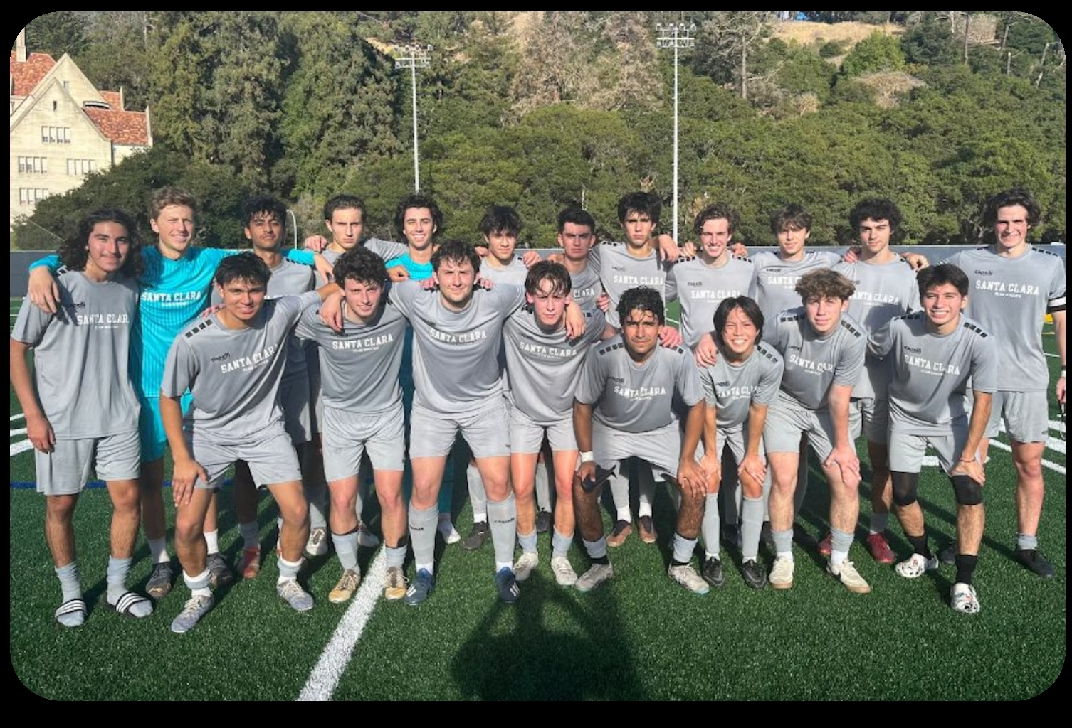
Men’s Club Baseball Men’s Club Soccer
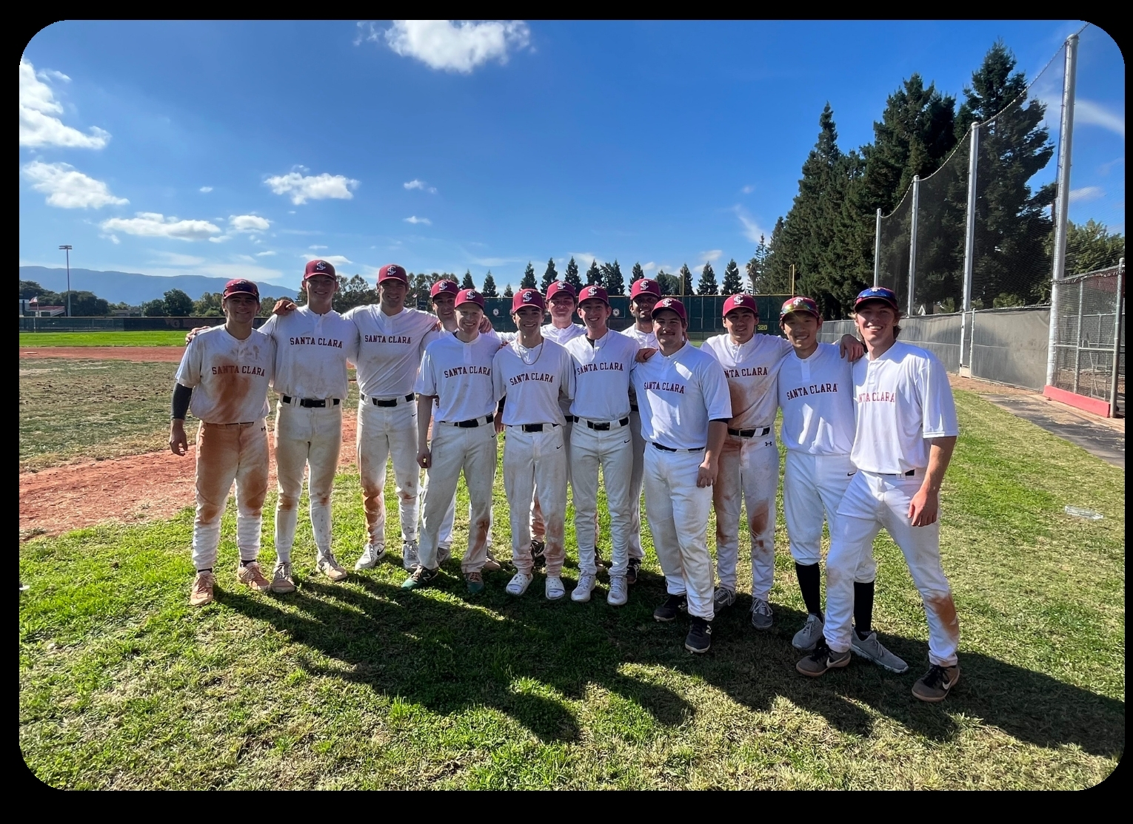

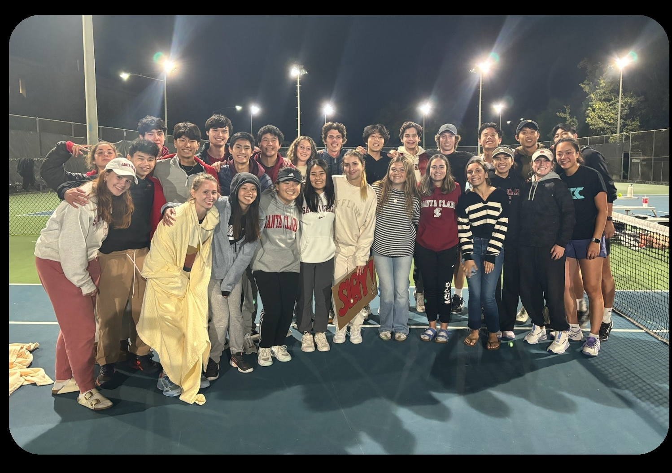
Women’s Club Soccer Club Tennis
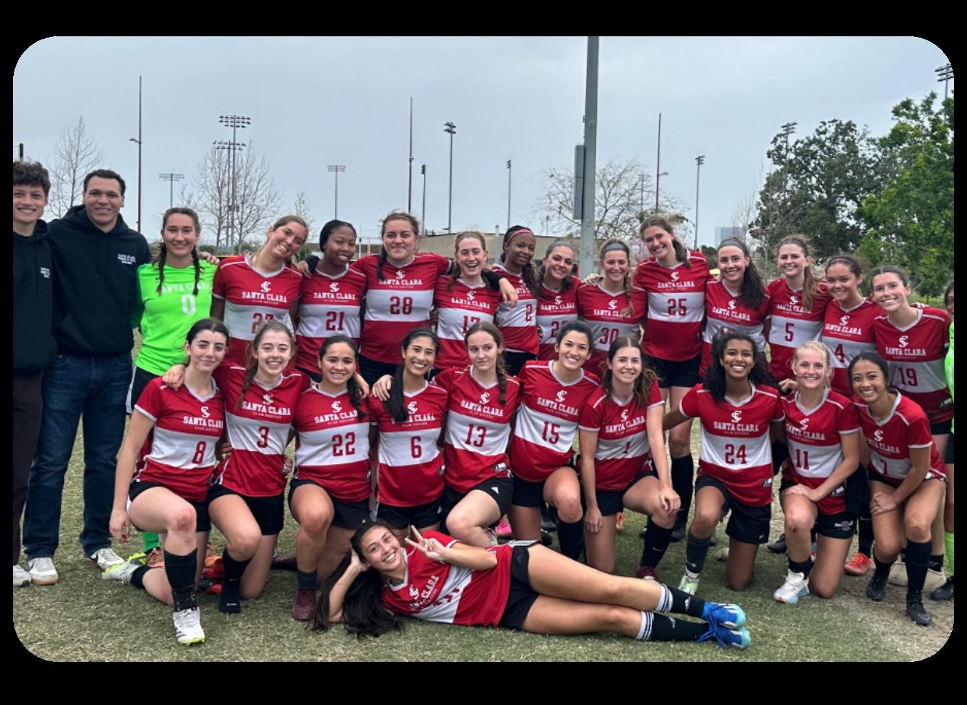

Notable Statistics
- Bowling placed 8th overall in West Coast Regionals.
- Boxing had 3 of their athletes place Top 4 in the nation and became All-Americans.
- Club Golf won 5 out of the 6 NCCGA events that they competed in and placed 14th in the nation.
- Men's Club Baseball competed in their very first season as a club.
- Men's Club Soccer won the league and went undefeated their last 11 games.
- Men's Ice Hockey made the playoffs for the second straight year and had a record of 8-1.
- Men's Ultimate Frisbee placed 8th at Regionals.
- Men's Volleyball placed Top 20 in National Competition and won League Championships for a second year in a row (first time in SCU history).
- Club Swimming had 3 of their athletes place Top 20 and one place Top 8 at National Championships.
- Club Tennis took gold in multiple tournaments throughout the year.
- Triathlon finished 12th in conference and placed 33rd at Collegiate Nationals.
- Women's Club Soccer finished with a record of 8-1-1, placing first in league, and earned a promotion to premier league for next season.
- Women's Club Volleyball placed 4th in league and gold bracket at Far Westerns.
- Women's Ultimate Frisbee attended Regionals.

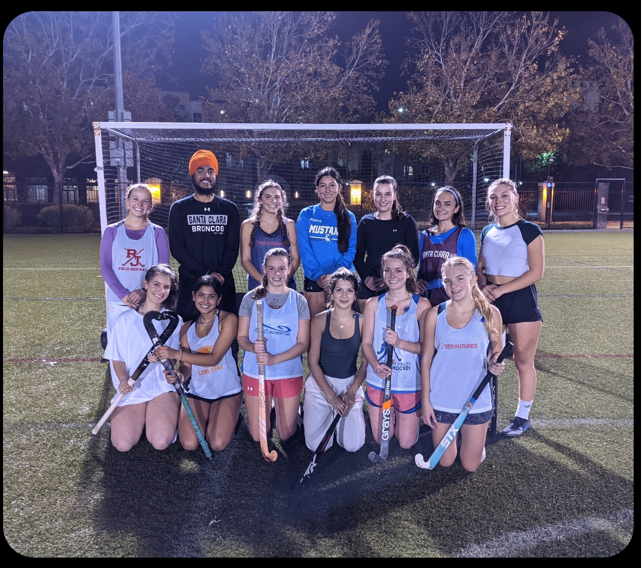
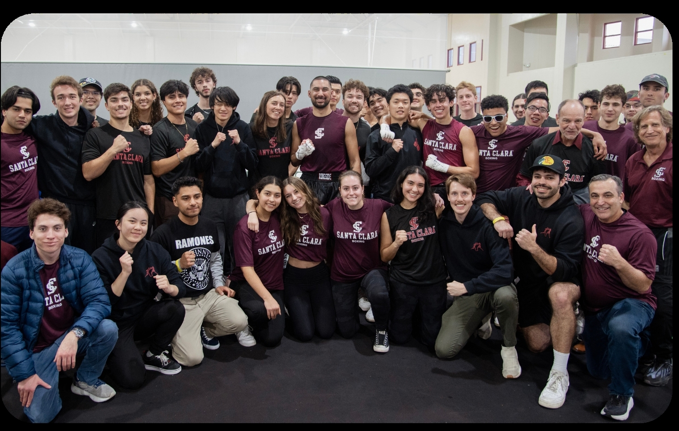
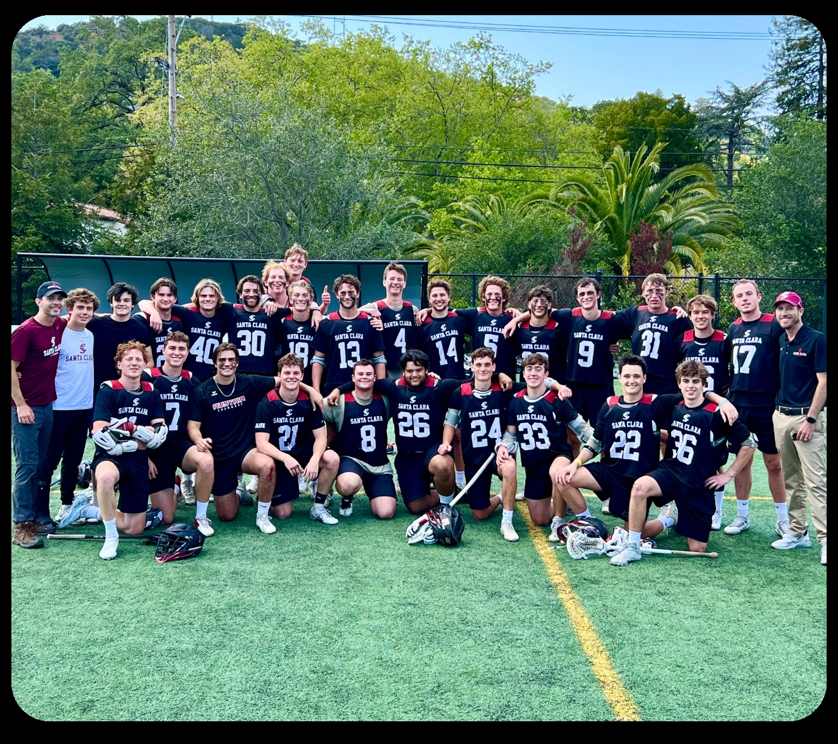

22 Programs, 724 Participants, 3.413 Average Cumulative GPA

Intramural Sports

Participant Breakdown
Intramural Sports offered a total of 18 sports during the ‘23-’24 academic year.
4,078 Total Participants
2,108 Unique Participants
67 Faculty/Staff Participants
5% of participants won a shirt (205/4,078)

Most Popular Leagues
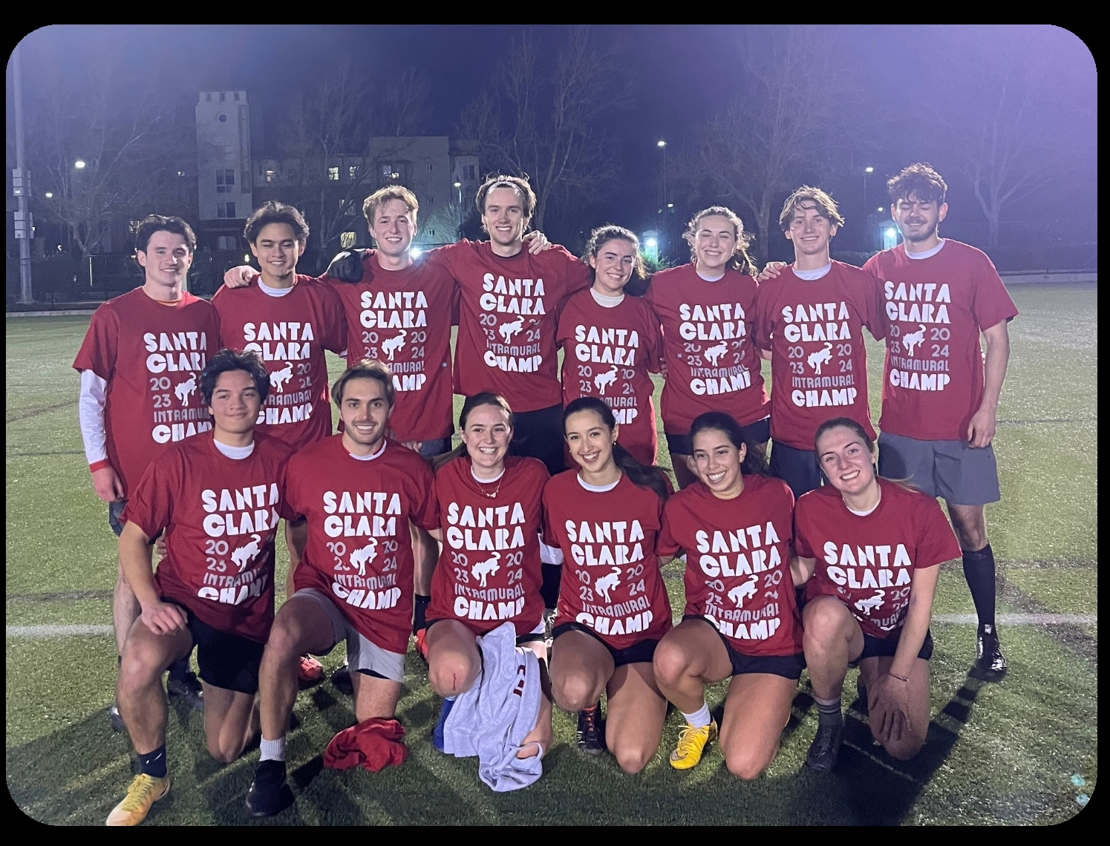
Basketball Soccer
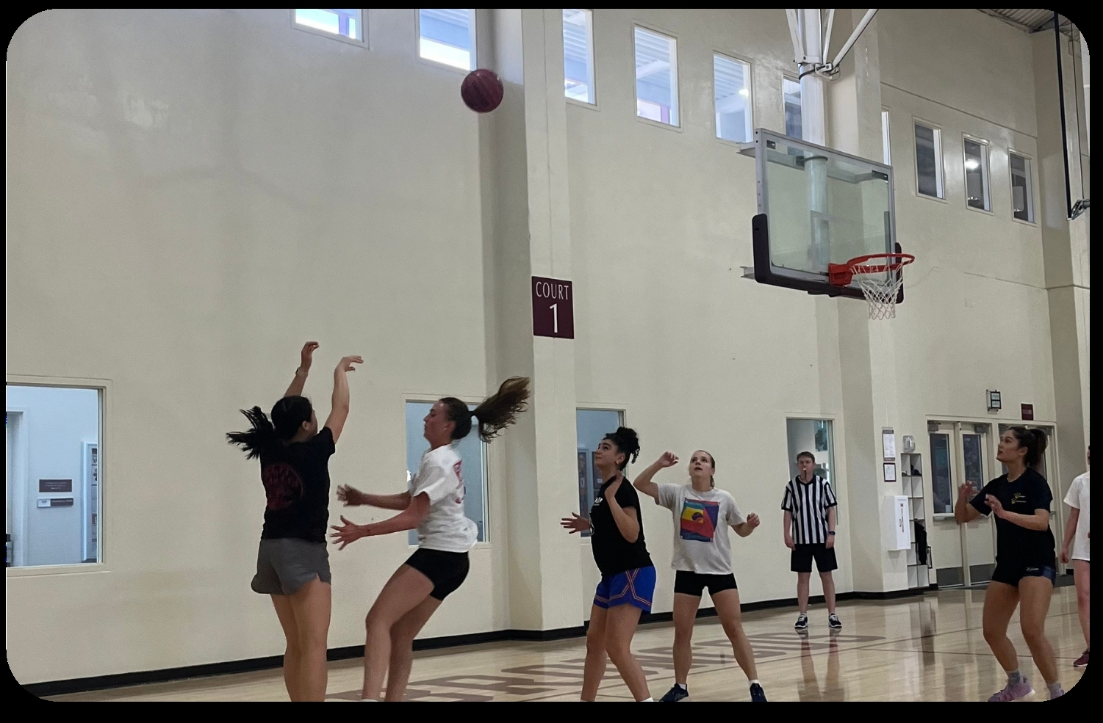

Beach Volleyball
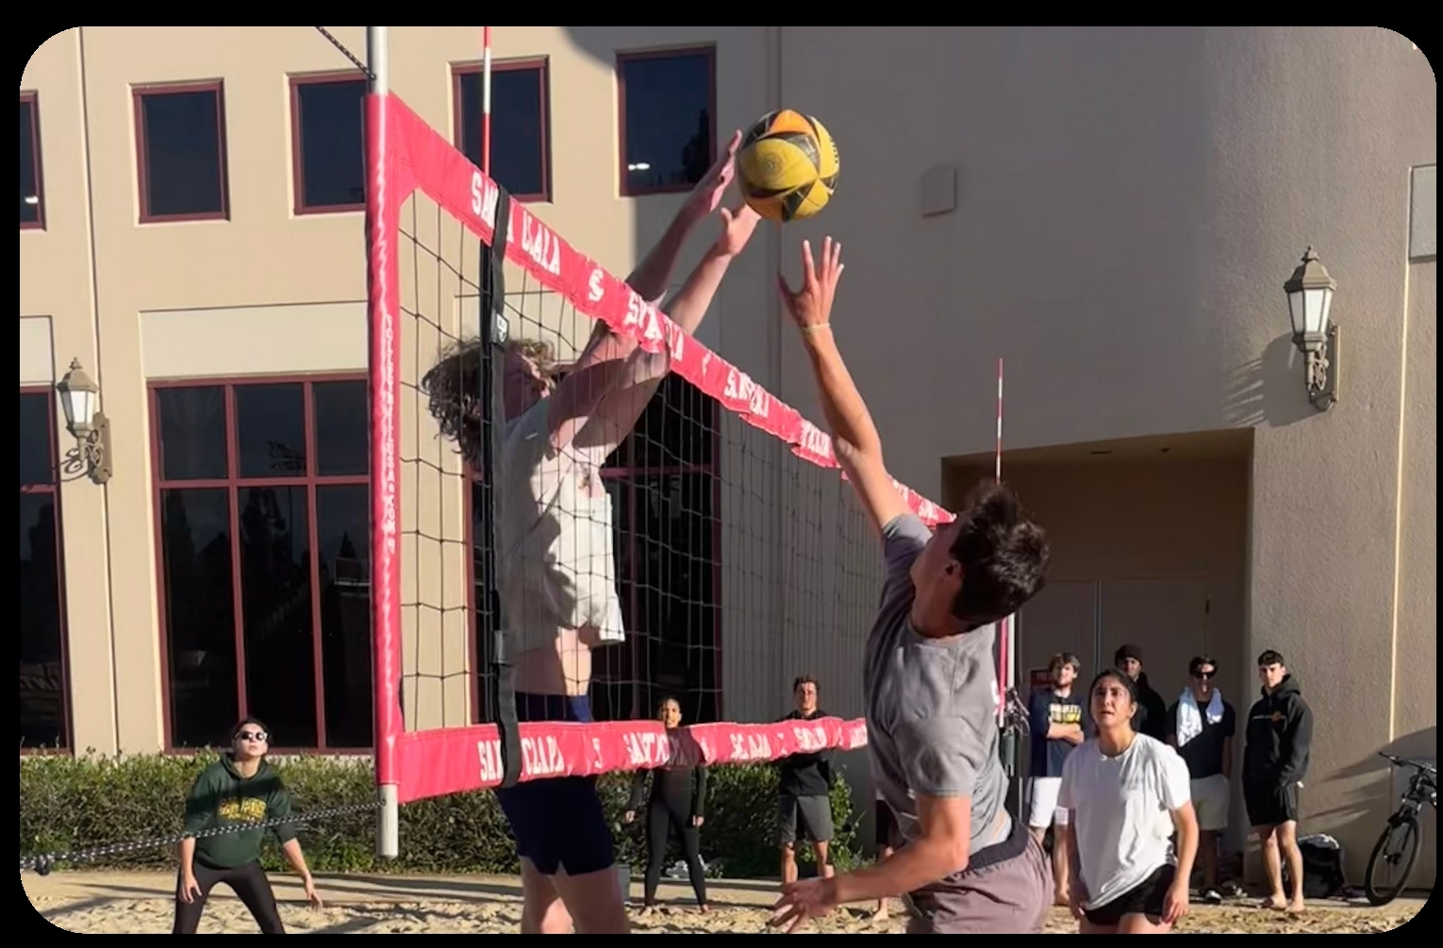

Tournaments
Pickleball and 3v3 Basketball were the most popular tournaments during the academic year.
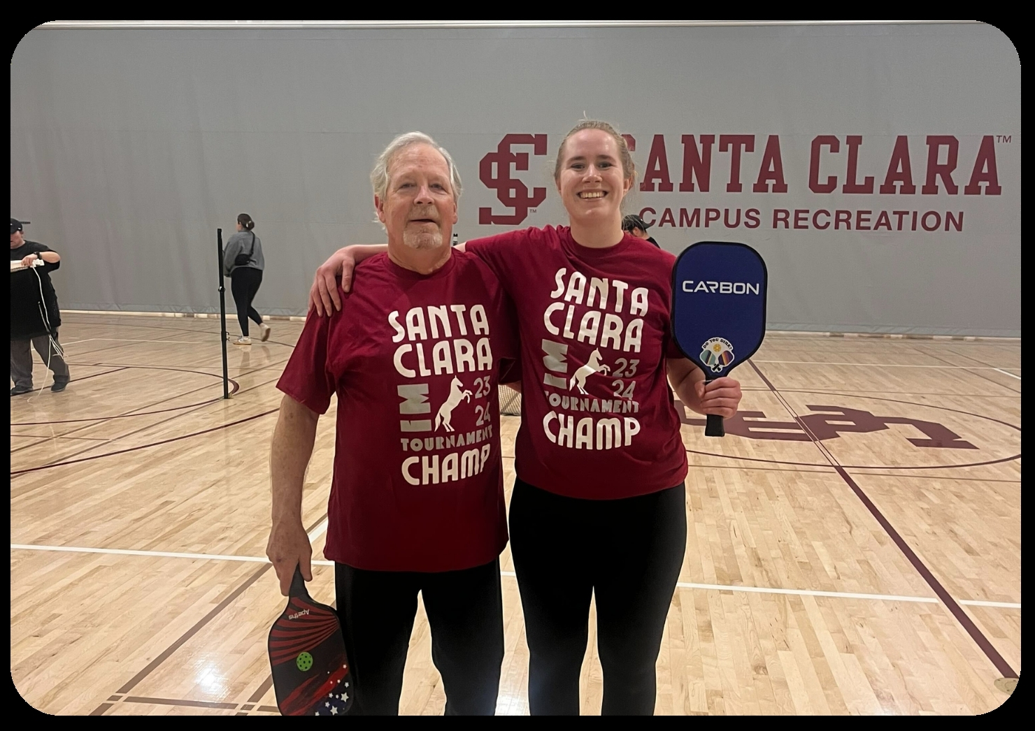

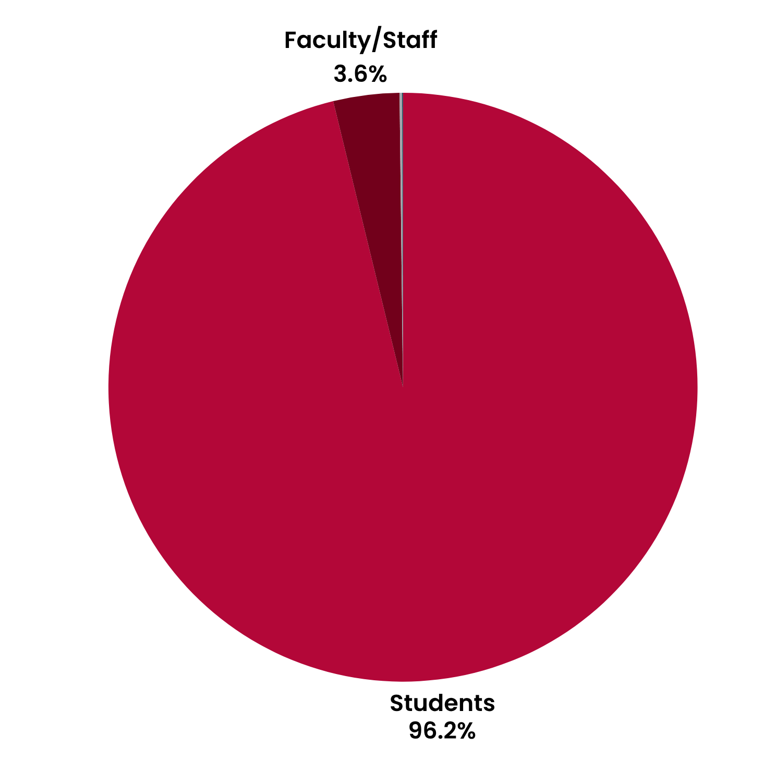

Fitness Classes

Participant Breakdown
The Fitness Class Program offered various classes during the ‘23-’24 academic year
33 Total Classes Offered
277 Total Class Sessions
2,134 Total Participants

2,071 Students
78 Faculty/Staff
3 Alumni
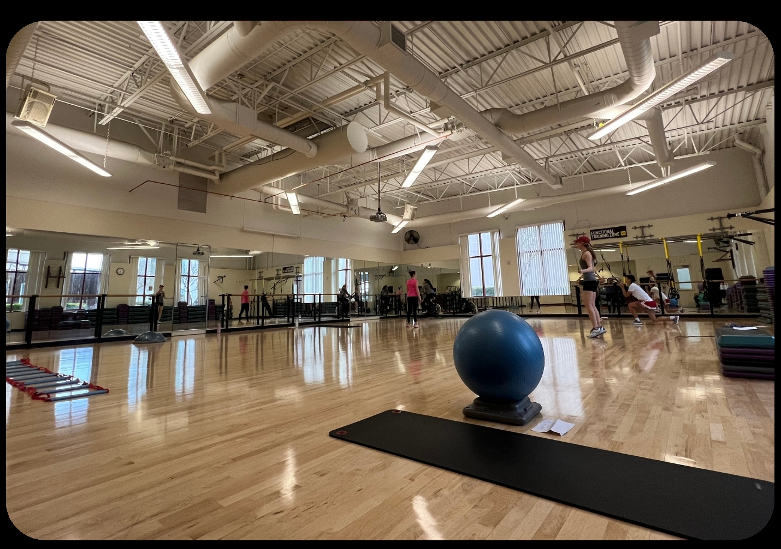
1 Guest
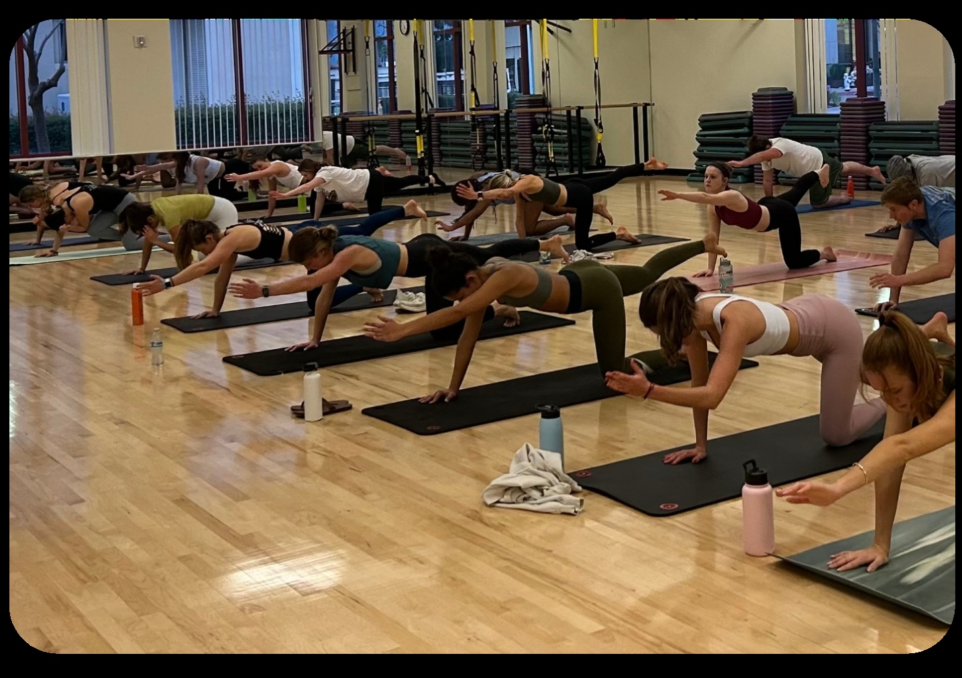

Bronco Kids All Sports Camp

The Bronco Kids All Sports Camp (BKASC) had a record-breaking attendance! There were 6 sessions held from June 19 to August 4 (no session July 3 to July 7).

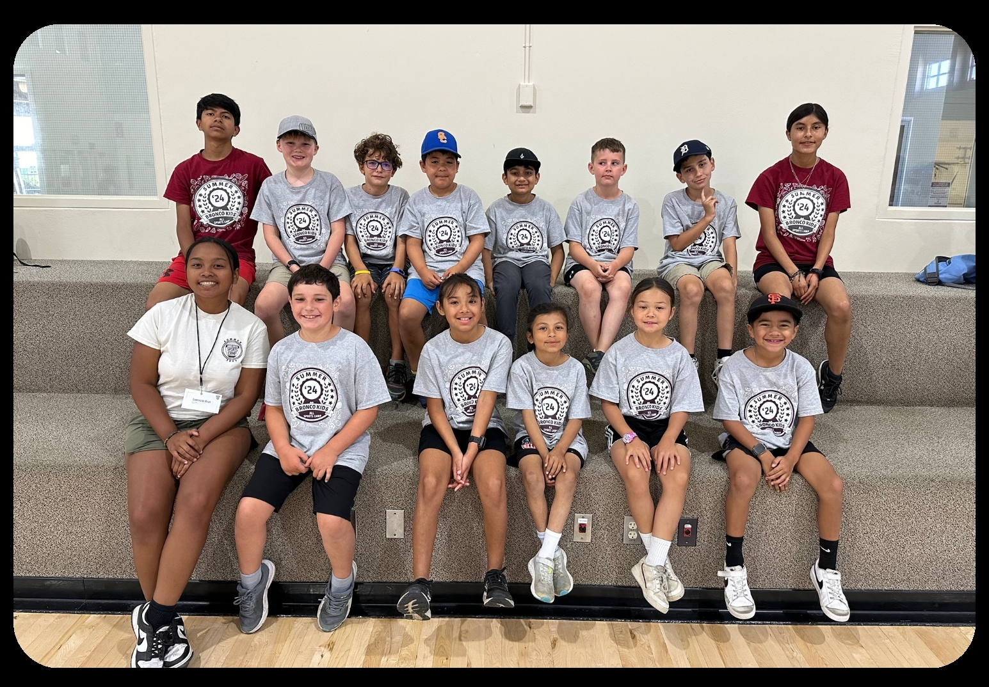
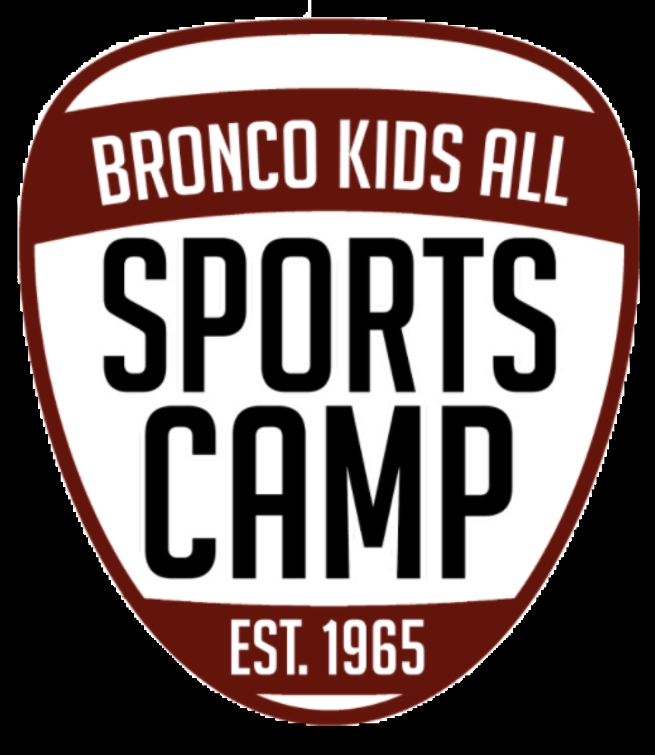

$198,486.84 Total Gross Registration Revenue
512 Total Campers
17.42% Increase in Total Campers from July ‘22 - June ‘23
82 Total CITs
12 Student Employees

Student Employment
159 Total Student Employees
141 Unique Employees
11 Students Held 2 Positions
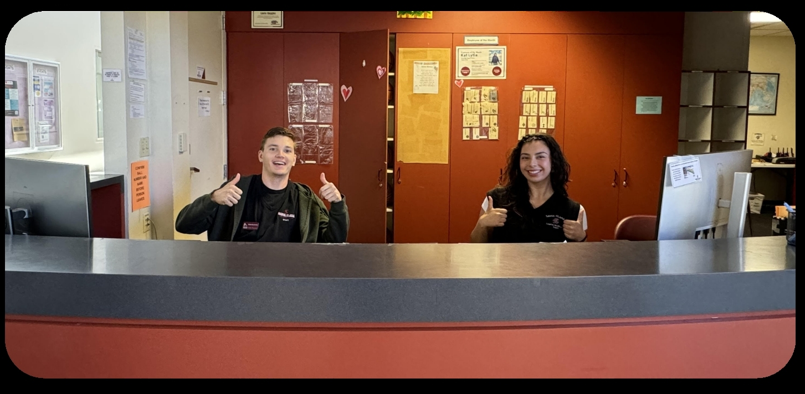

71 Faculty Staff Positions
41 Intramural Sports
4 Bellomy Field Supervisors
8 Student Fitness
12 Bronco Kids All Sports Camp
23 Student Coordinators

44 New Hires from July ‘23 - June ‘24

All Student Employees are certified in American Red Cross CPR/AED/First Aid

We spent $504,479 on student wages for ‘23 - ‘24. ($470,000 was allocated by the University, and $34,479 came out of Campus Recreation’s revenue i.e. their operating budget).
