Annual Report Campus Recreation

2024-2025

25 Years of the Malley Center
The Pat Malley Fitness and Recreation Center opened its doors on September 15, 1999.

In 2024, we held the following events to celebrate the Malley Center’s 25th anniversary:

Sunday, September 15
On this day, we handed out Pat Malley stickers to every 25th person entering the facility.

Friday, October 11
On this day, we hosted alumni tours with 14 Campus Recreation alumni and 24 alumni in attendance.

Wednesday, October 16
On this day, we hosted two events: a Faculty/Staff event and a Student event.

During the Faculty/Staff event, we held a pickleball tournament with eight participating teams, and the top three finishers received a 3D printed pickleball trophy.

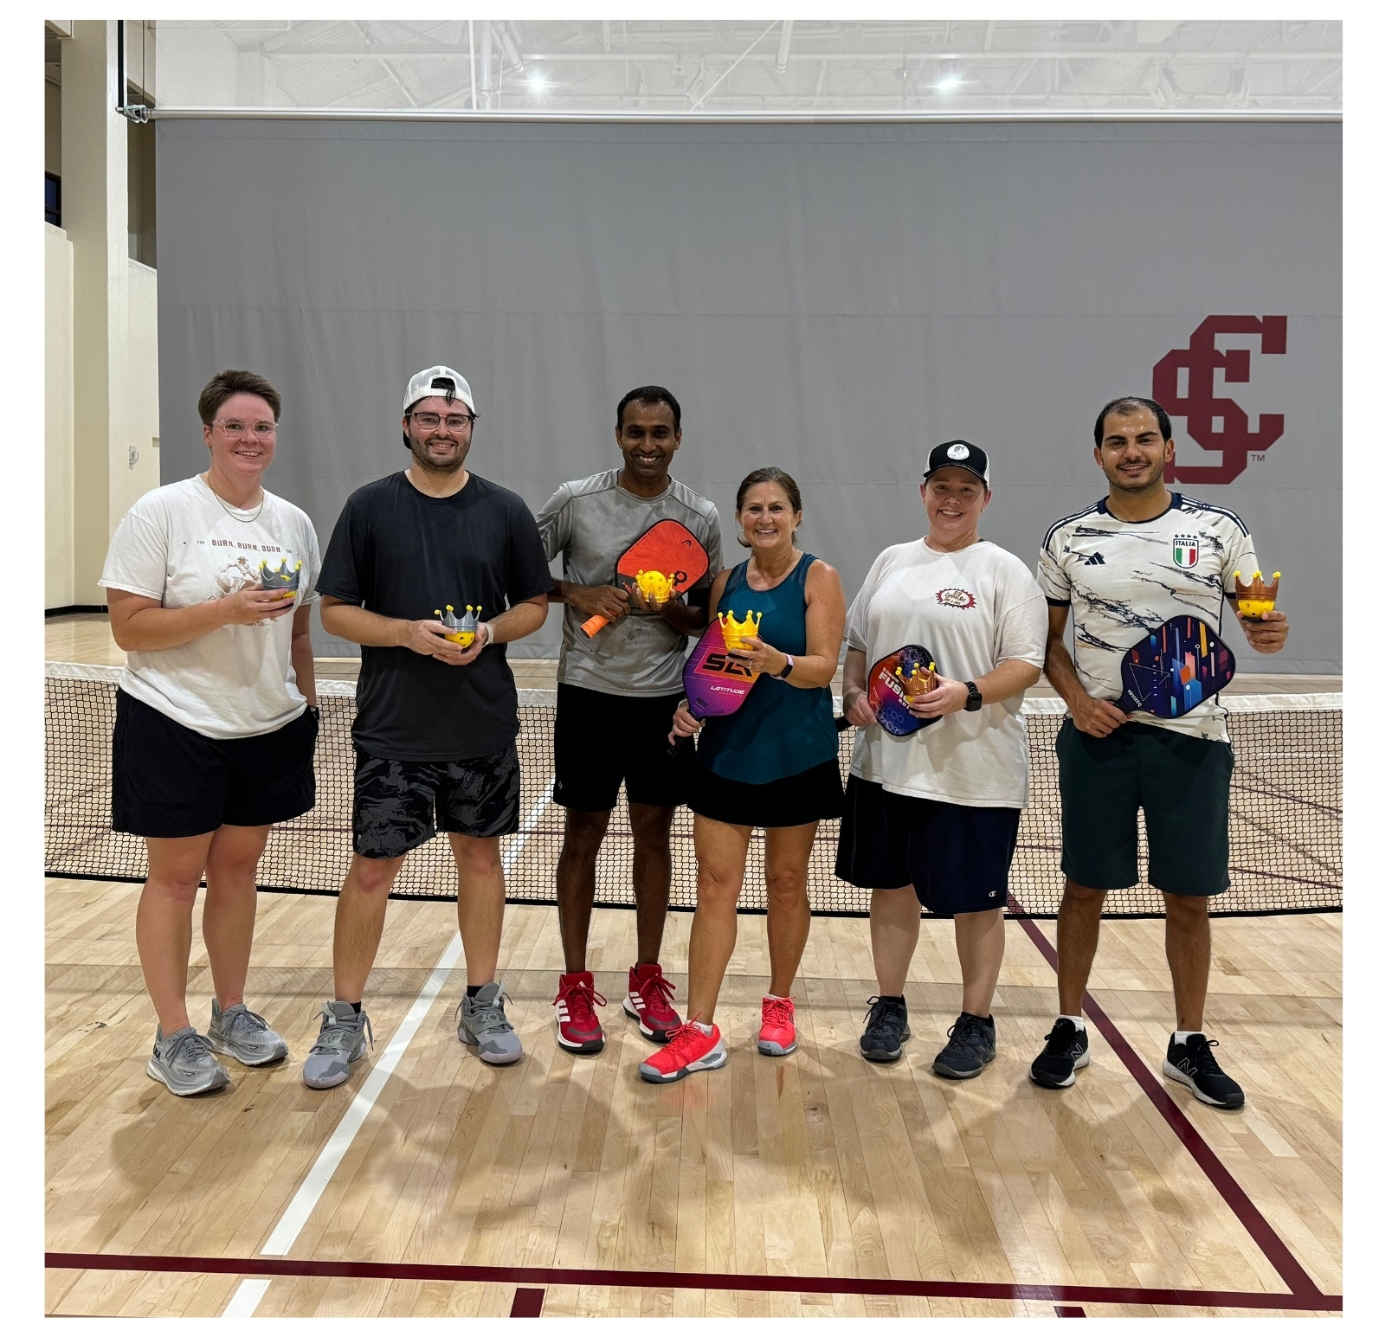
During our Student event, we held the Intramural Dodgeball tournament with four participating teams, served birthday cake, cupcakes, and pizza, raffled 25 items, and gave away 500 t-shirts.
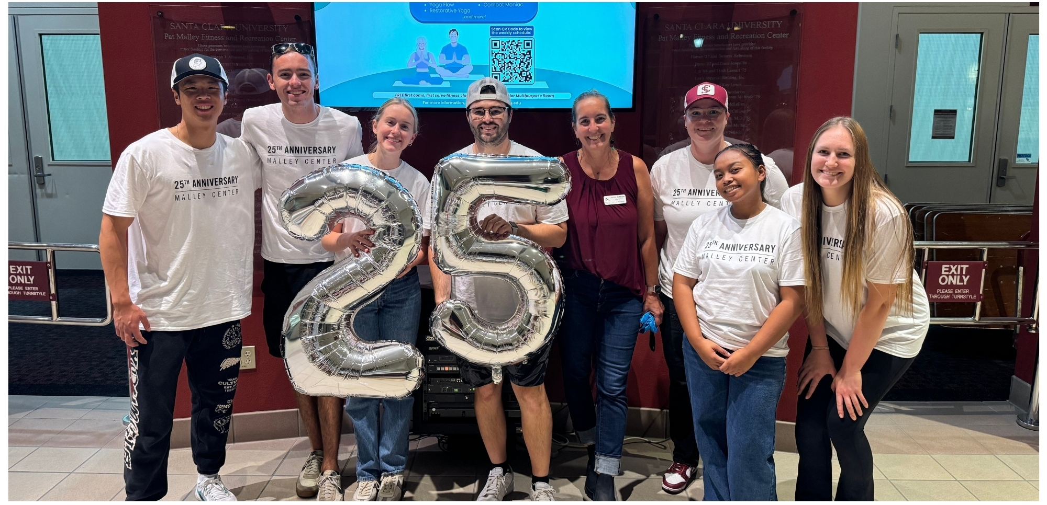

Donation Drive
Campus Recreation raised $5,895 donations between September 14 and April 23. The donations were put towards new dumbbells for the Multi-purpose Room and racks. Since then, we have seen that each hour, on average there are 6 people using the new weights in the Multi-purpose Room, when not occupied by different programs.

Malley Center Check-in Data
268,337 Total Check-ins July ‘24 - June ‘25
1.06% Increase in Check-ins from July ‘23 - June ‘24

Daily Usage
The first day of Fall Quarter 2024 became our busiest check in day with 2,045 check ins.
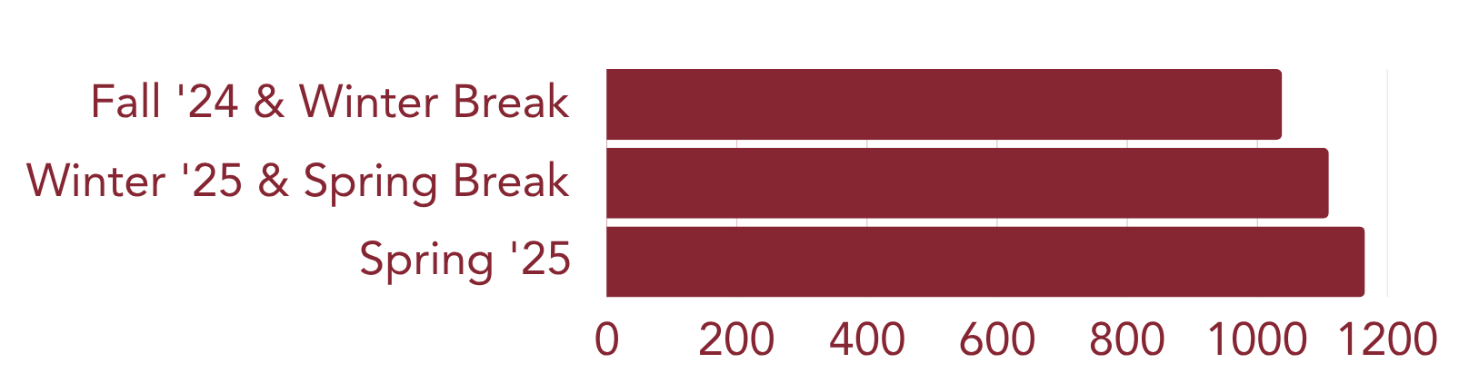

Weekly Usage
The weekly usage of the gym averages 1 to 6 times a week. For example, 489 people used the gym 2 times a week, and 231 people used the gym 5 times a week.
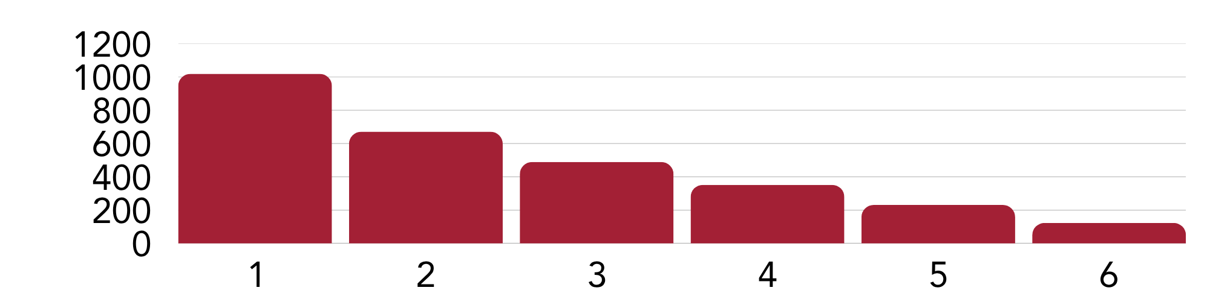

Monthly Usage
September was on summer hours until the last 8 days, and in December we were only open 13 days before closing for Winter Break.
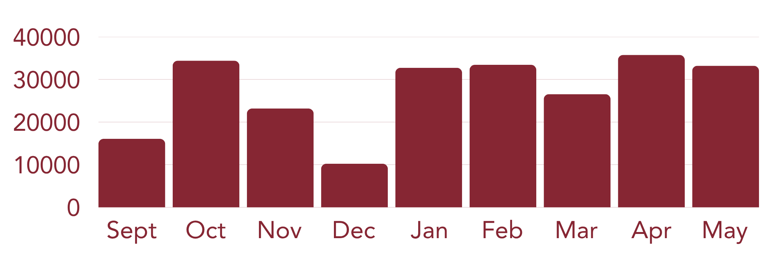

Guest Data
From July 1, 2024 to June 30, 2025, Campus Recreation sold a total of 2,088 guest passes, generating $55,970 in revenue.

Visitor Data
There were a total of 1,138 visitors that came to visit the Pat Malley Fitness & Recreation Center, 488 of those visitors being prospective students and their families.

Facility Updates
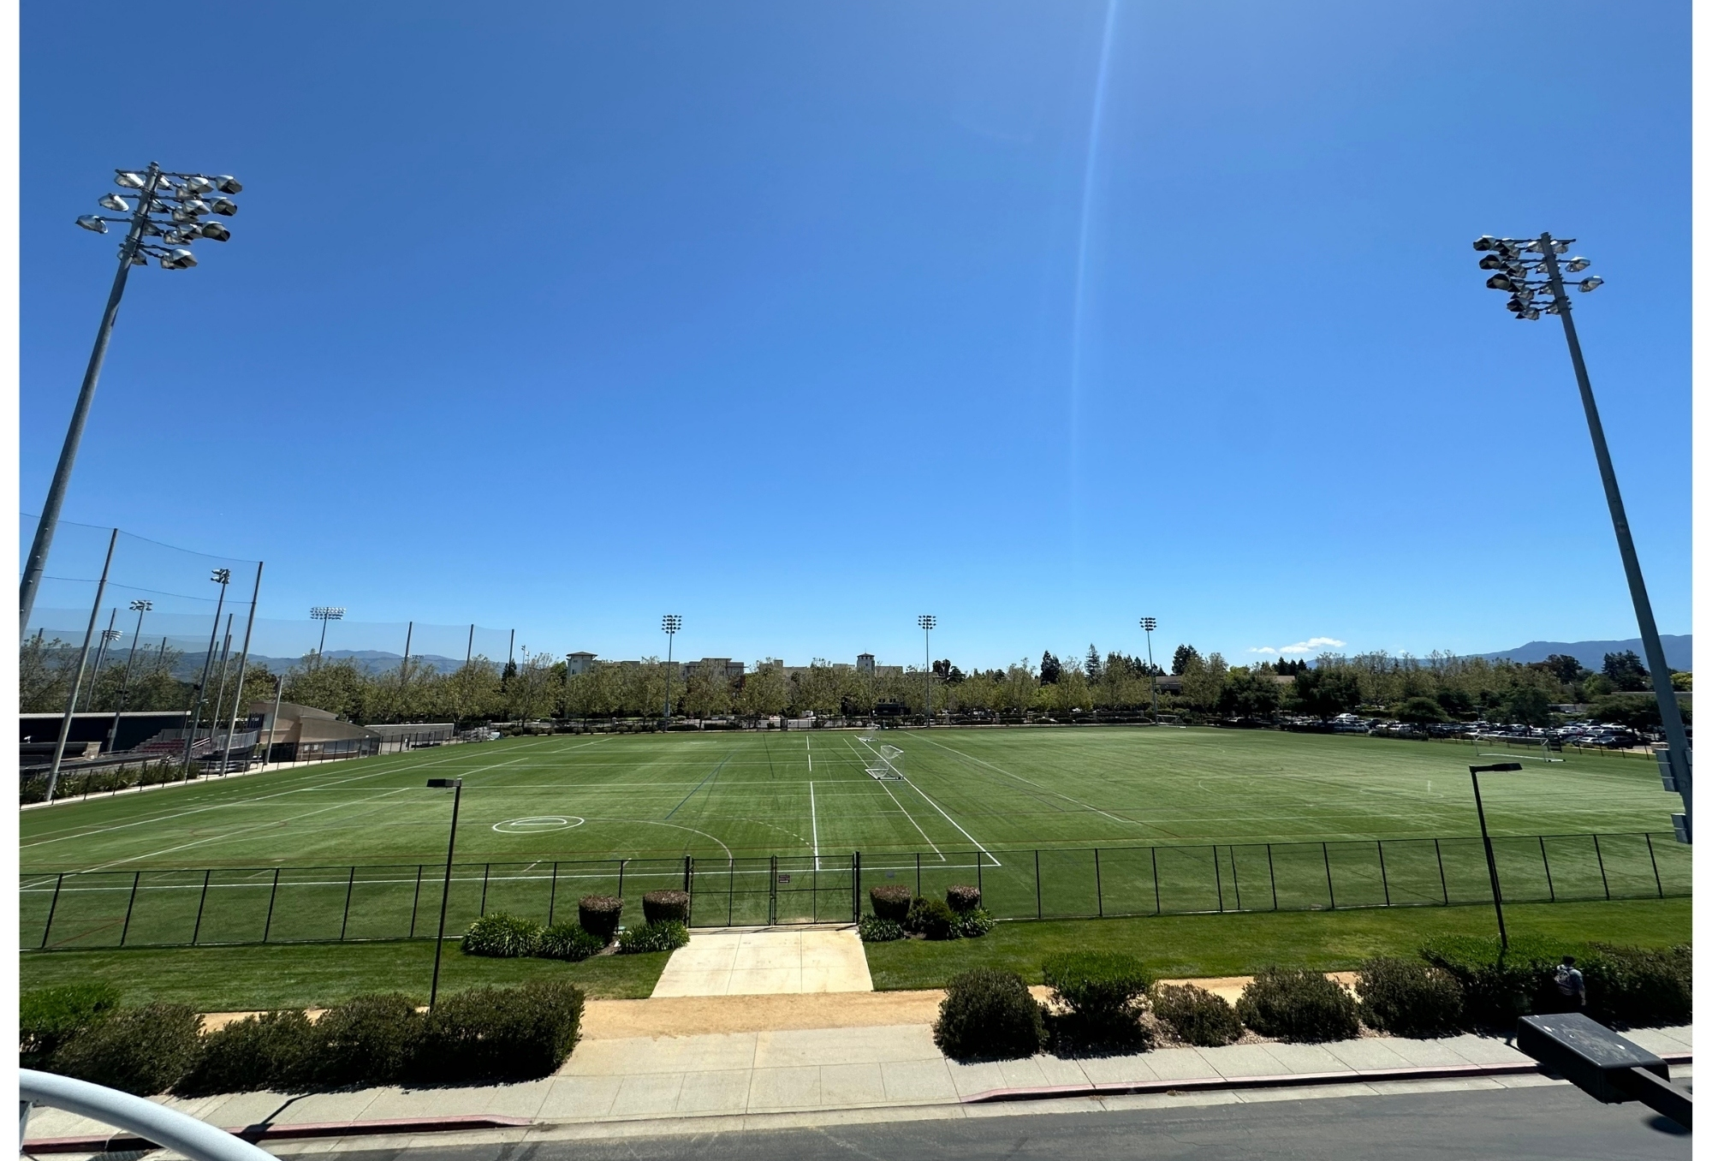

Bellomy Field Replacement Turf Project
Monday, August 5, we began to replace the turf and repaired the padding below the turf at Bellomy Field. While the project was delayed until Sunday, October 24, we were still able to hold the Intramural Sports Flag Football league and Club Sports events and practices during the Fall Quarter. In addition, the Men's Lacrosse team purchased new shot clocks to be used in their upcoming season.

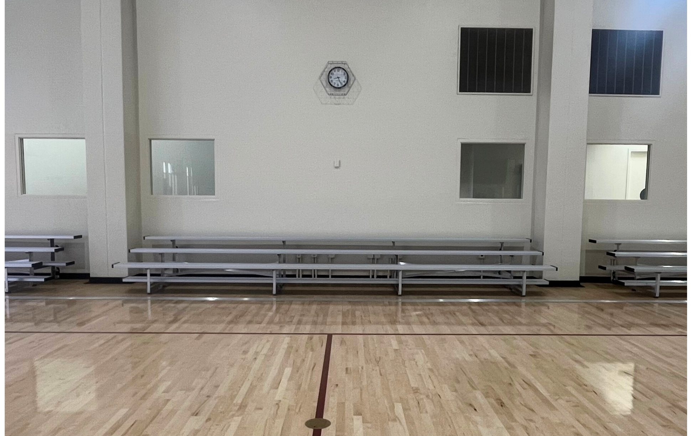
Benches on the Malley Center Courts
In August of 2024, we removed the old carpeted court benches that were original to the building. We installed six metal bleachers, three on the walls of Court 1 and another three on the walls of Court 3, increasing court seating capacity by 150%.

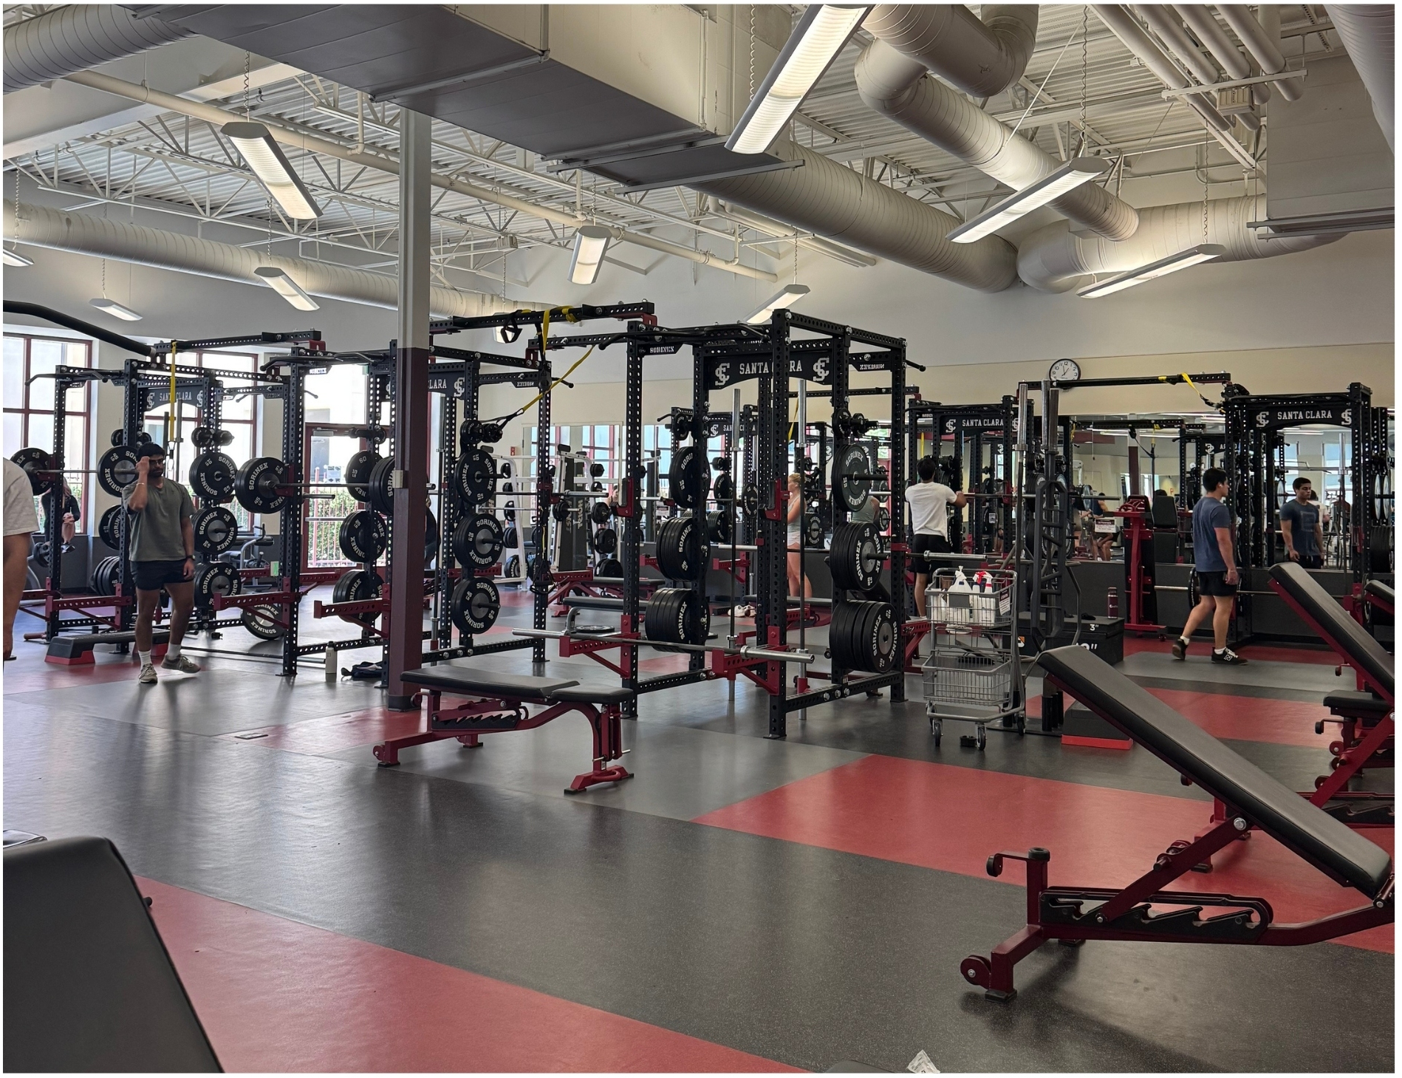
Weight Room Heavy Side New Additions
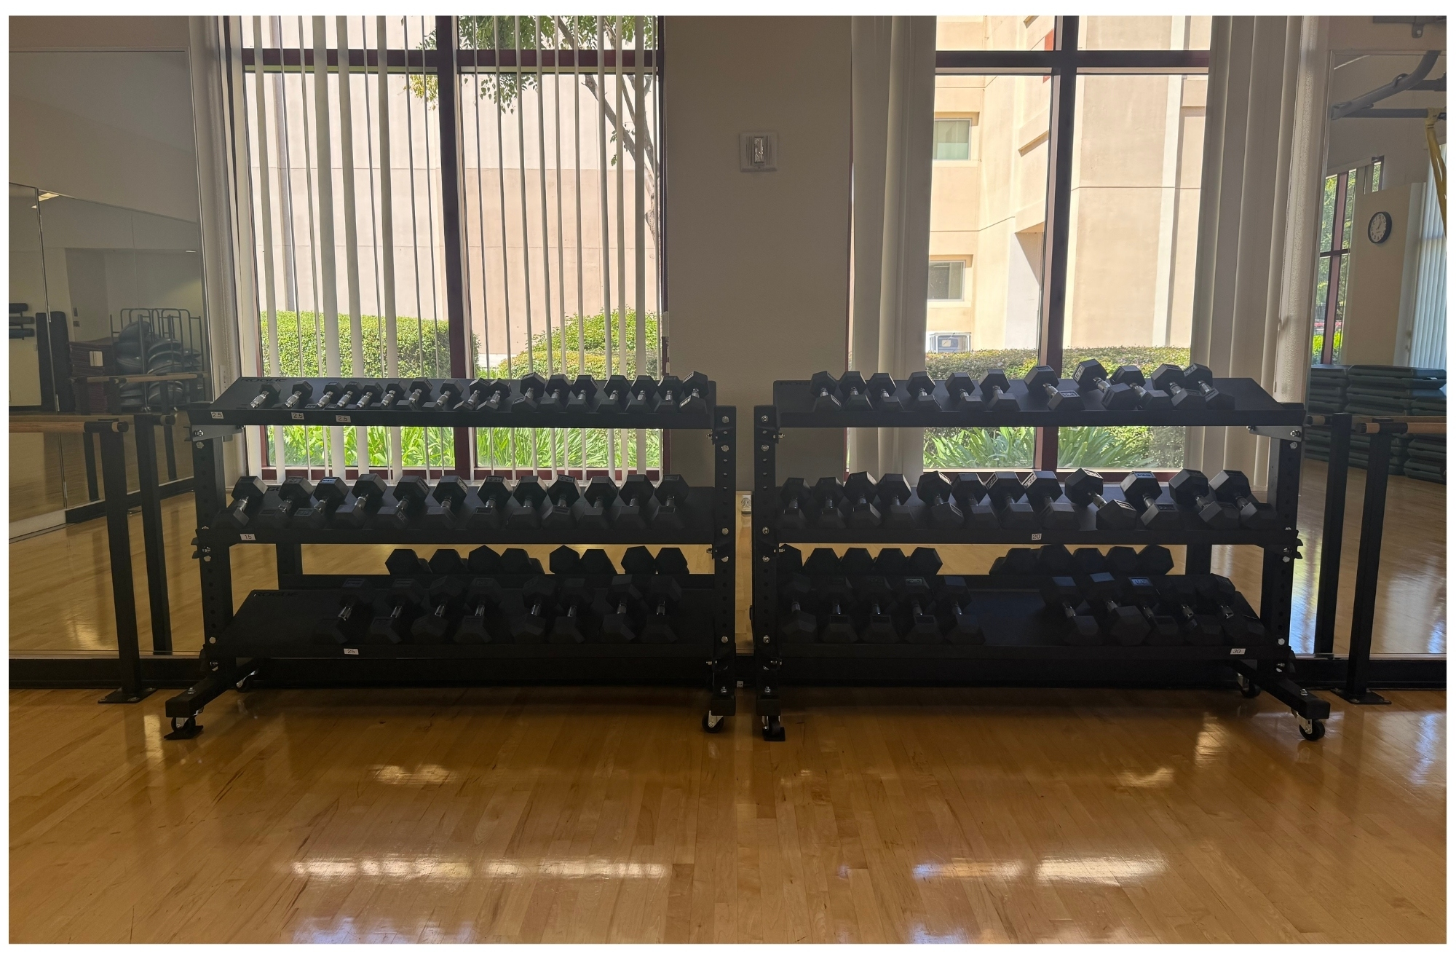
On Friday, December 13, we moved all the equipment off the heavy side to clean the floor over the weekend. Monday, December 17, we installed nine new squat racks & cut out pieces of the Mondo Sport Floor to create drop zones. All new racks have rubber plates from 2.5 - 45 lbs. and moveable adjustable benches. In addition, this project allowed for TRX cables to be added to some of the stations. Other weight room upgrades this year were the replacement of six treadmills, three adaptive motion trainers, and three ellipticals.

Multi-purpose Room Weights
During Thanksgiving break, we installed two dumbbell racks for the start of the weights in the Multi-purpose Room. These racks held three pairs of weights 2.5 - 20 lbs., then in May 2025, we filled the racks with three more pairs of weights 22.5 - 30 lbs.

Club Sports
There are 21 active competitive club sport teams that compete at the local, regional, and national levels against other universities.

Academic Highlights
688 Student Athletes
3.42 Cumulative GPA
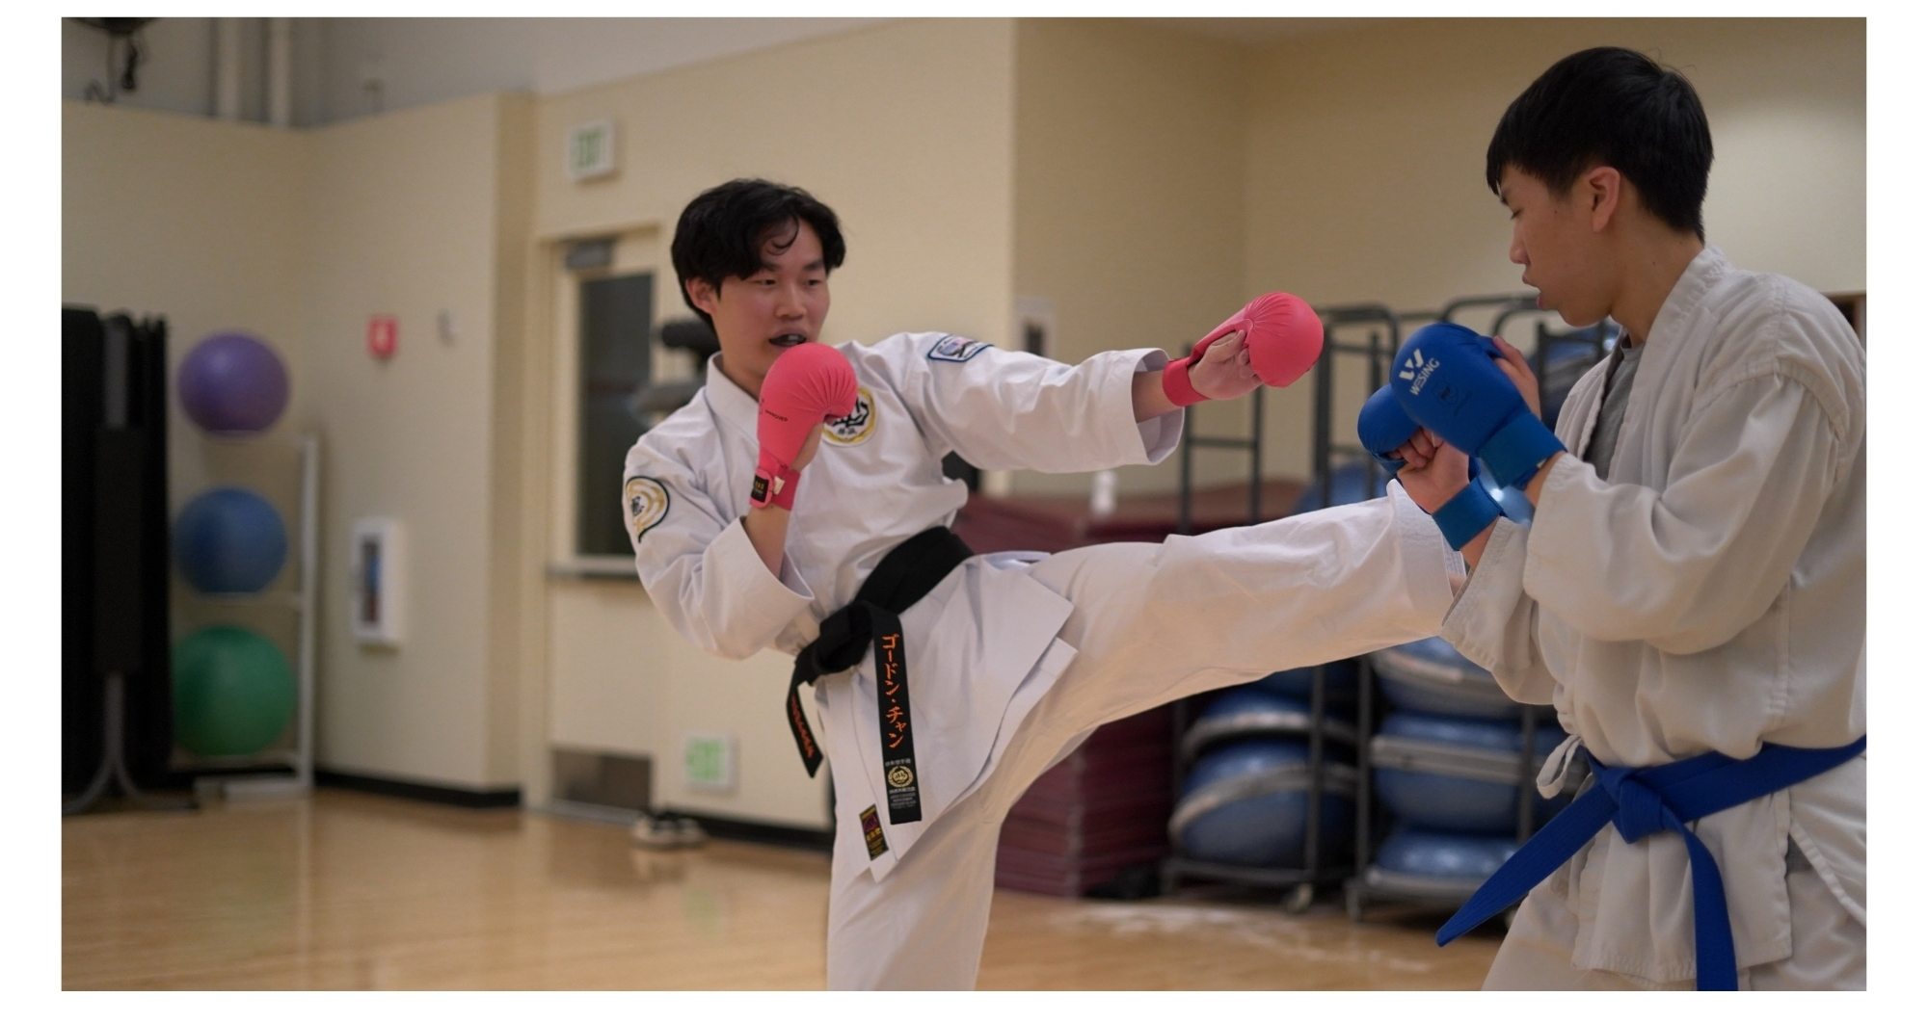

Awards
13 Club Sport Student Athletes received All-American, All-Conference, or All-Leagues awards.
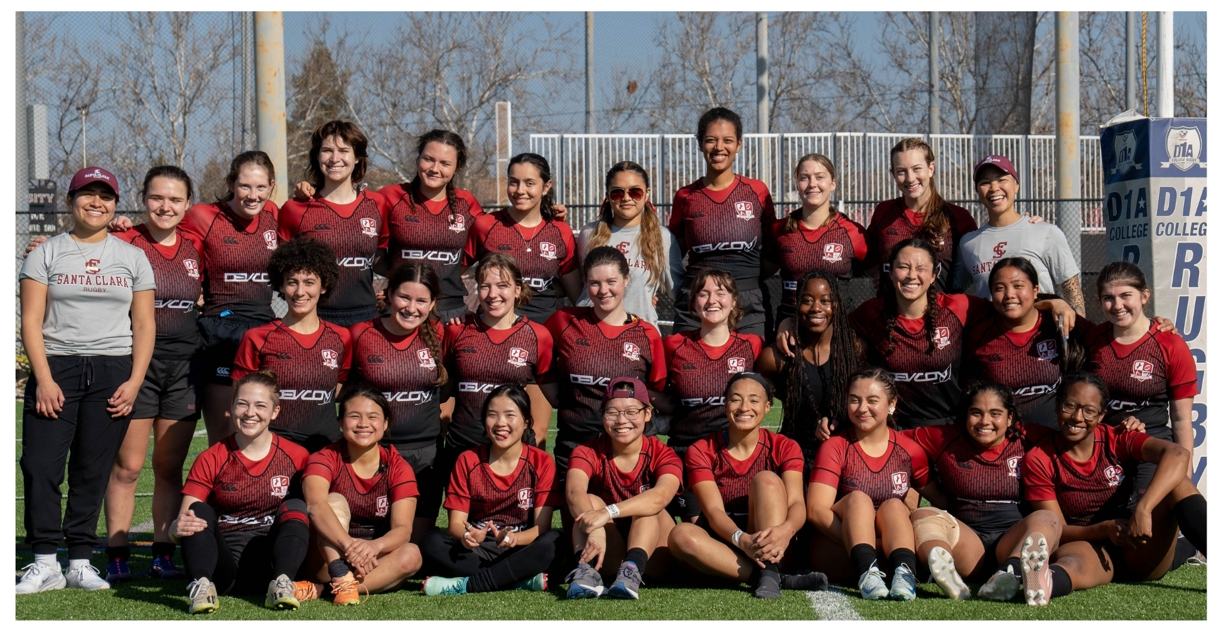

Day of Giving
The Club Sports program raised a total of $253,133 from 770 gifts

Percentage Increase from 2024 Day of Giving
56.54%
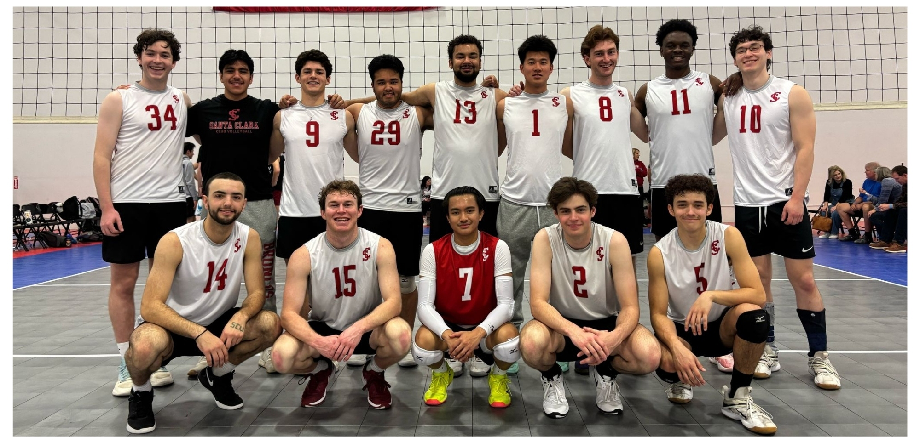

Notable Stats
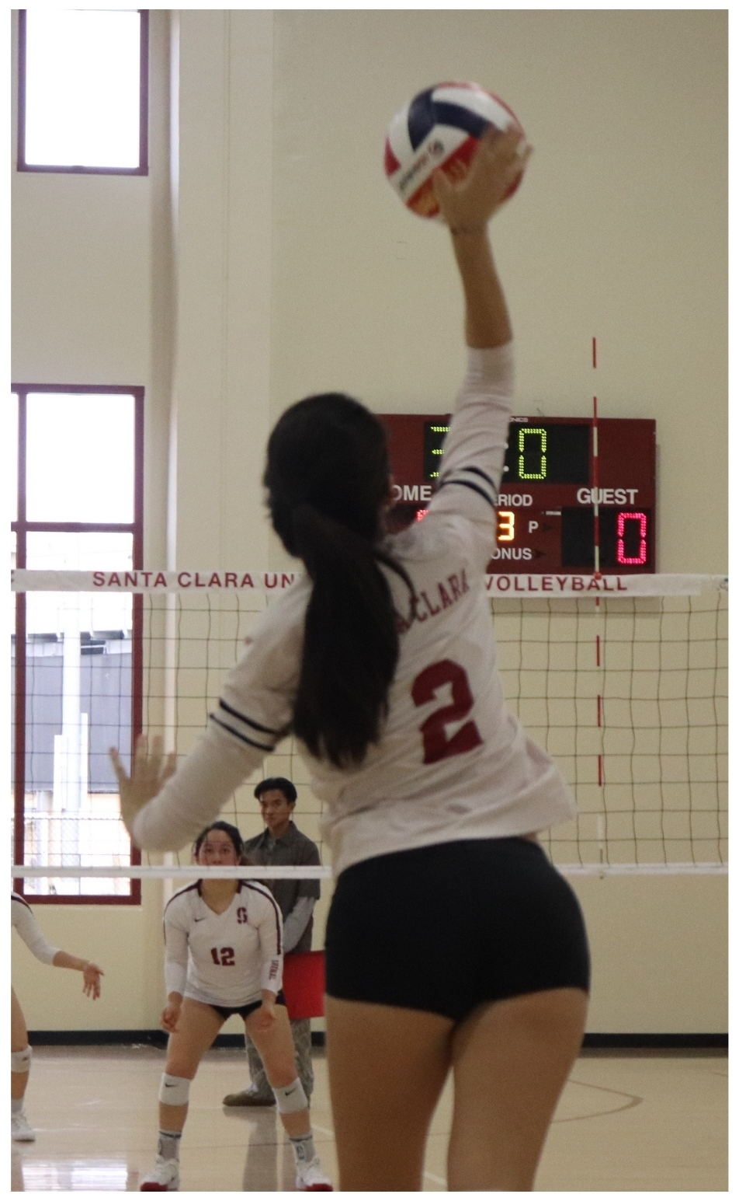
- Bowling made their first second-round appearance
- Men’s Club Baseball were Pacific North Champions with a conference record of 17-1, an overall record of 21-5, and are ranked as 7th NCBA DIVII team in the country
- Men’s Ice Hockey had an overall record of 11-10-1, a league record of 6-2-1, and made playoffs for a third straight season
- Men’s Volleyball had an overall record of 16-15, placed 24th in the nation, and 3rd at Far Westerns
- Swimming placed 15/32 at CCS Regionals (Men’s team placed 8th), placed 43/131 at CCS Nationals (Men’s team placed 23rd). They had 18 swimmers attend CCS Regionals and 11 swimmers attend CCS Nationals.
- Club Tennis had an overall record of 29-15, won UC Davis Cowtown Tournament for the second time in a row, qualified/competed in Georgia at Nationals.
- Triathlon finished 12th out of 20 amongst the west coast collegiate teams, and placed 33rd in the mixed team relay at Nationals.
- Women’s Club Volleyball placed 1st at Far Westerns, 4th in the League, 9th in the Nation, and was placed in the Gold Bracket at the Las Vegas Tournament

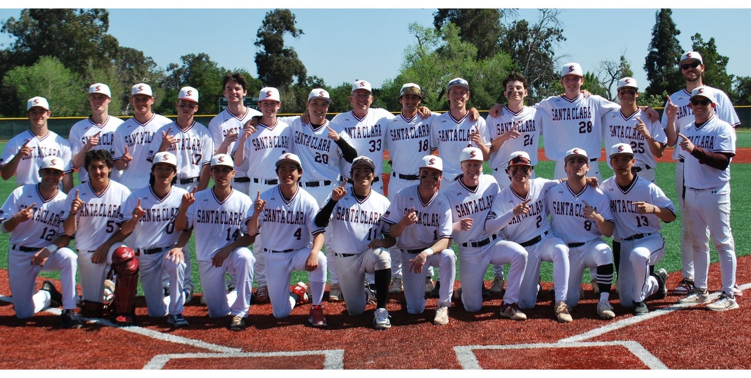

Intramural Sports
Intramurals Sports offered a total of 18 sports during the ‘24-‘25 academic year.

Participation Breakdown
Total Participants: 3,849
Unique Participants: 1,947
Faculty/Staff Participation: 63

Breakdown by Class Year
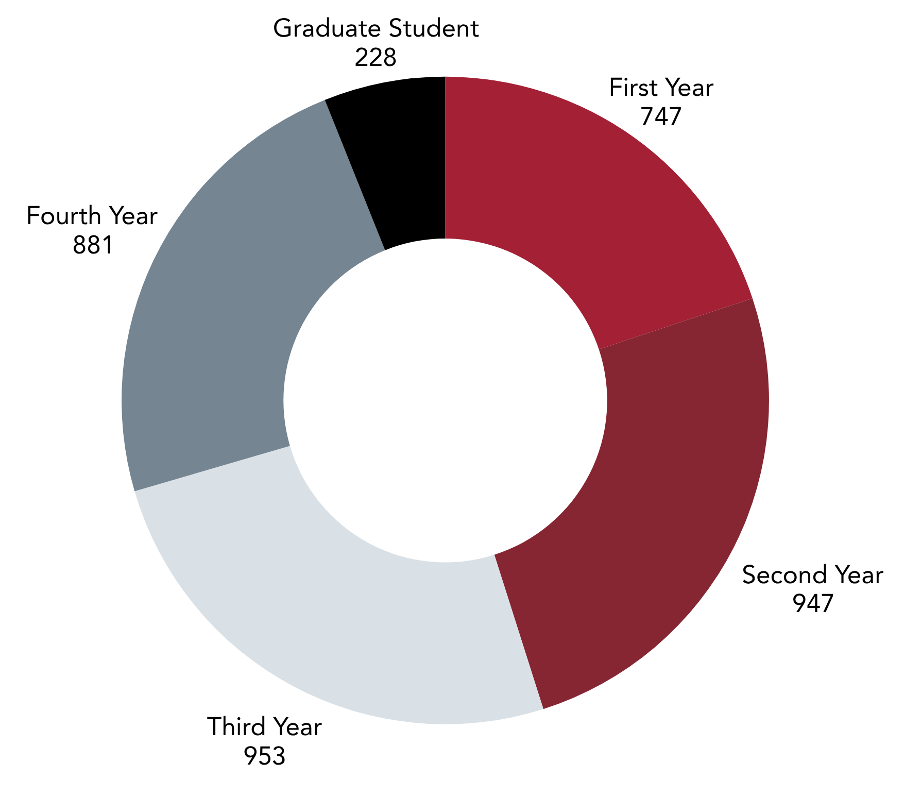

Fun Statistic
5% of participants won an IM Champion shirt
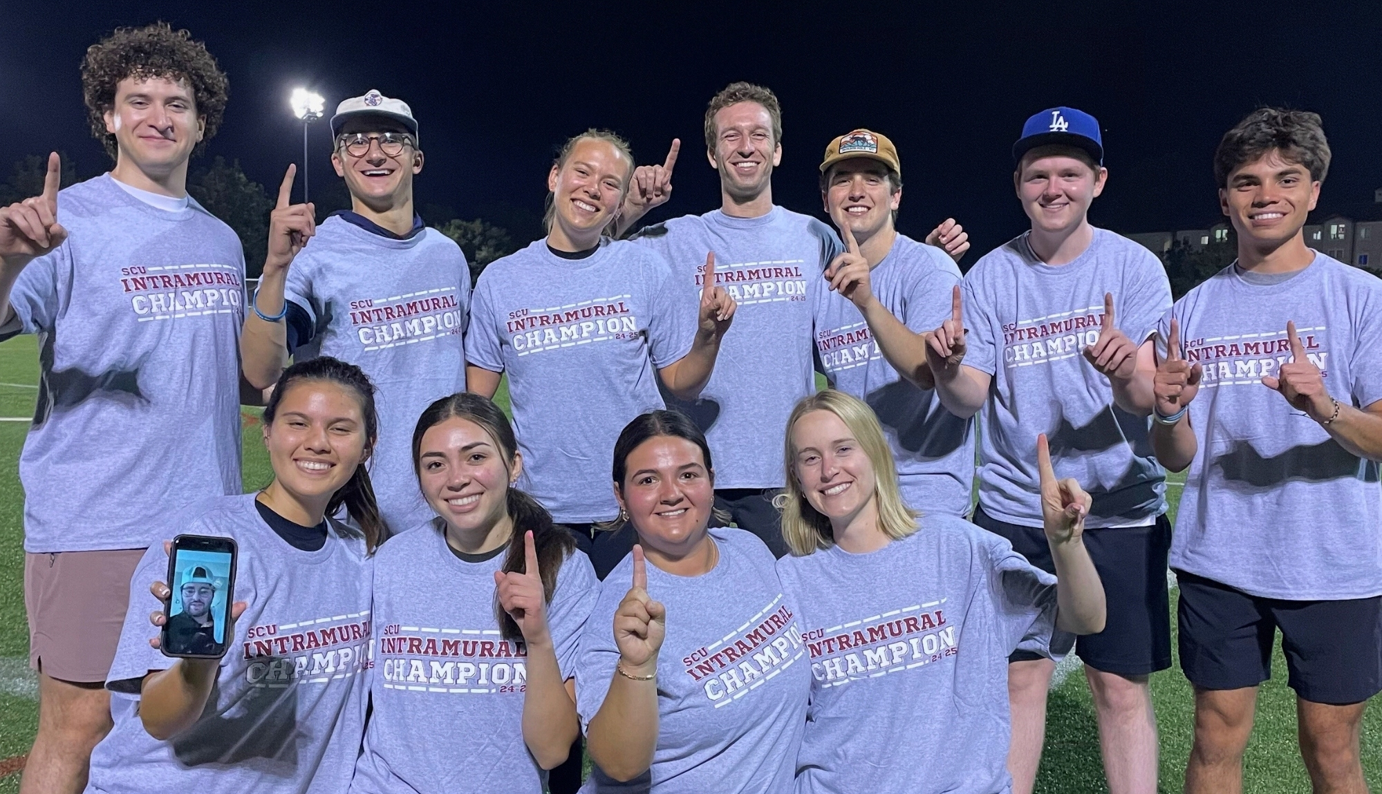

League and Tournament Facts
Our most popular leagues this academic year were Basketball, Beach Volleyball, and Pickleball.
3v3 Basketball and Pickleball were the most popular tournaments during the academic year.

Fitness Classes
The Fitness Class Program offered various classes during the ‘24 - ‘25 academic year.
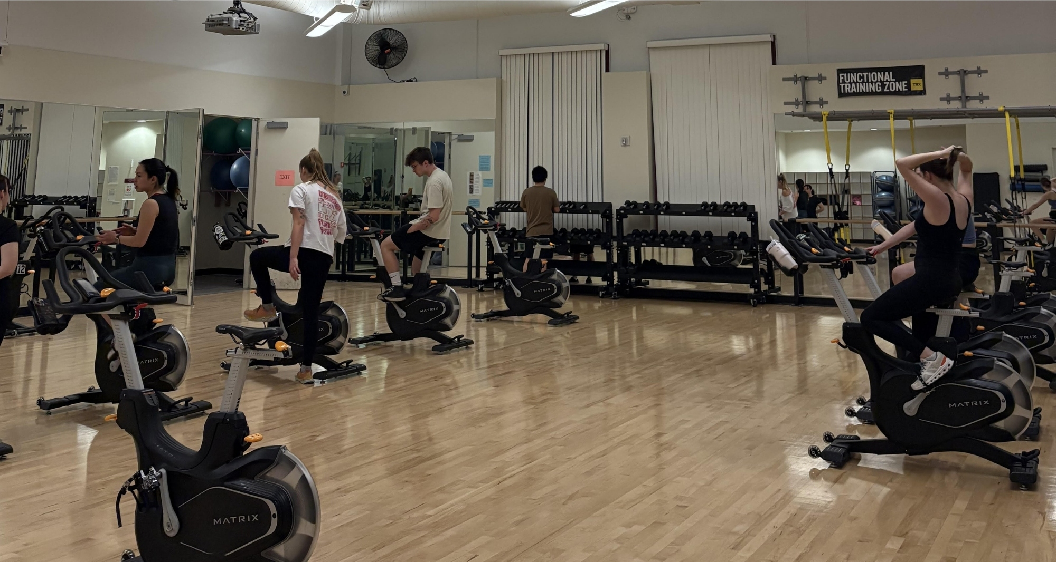

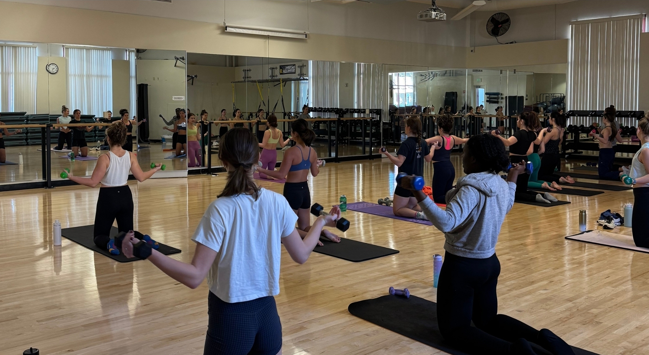

Statistics
Total Classes Offered: 56
Total Finals Week Classes Offered: 20
Total Class Sessions: 487
Total Participants: 3,567
Percentage Increase in Participants: 67.15%

Participation Breakdown
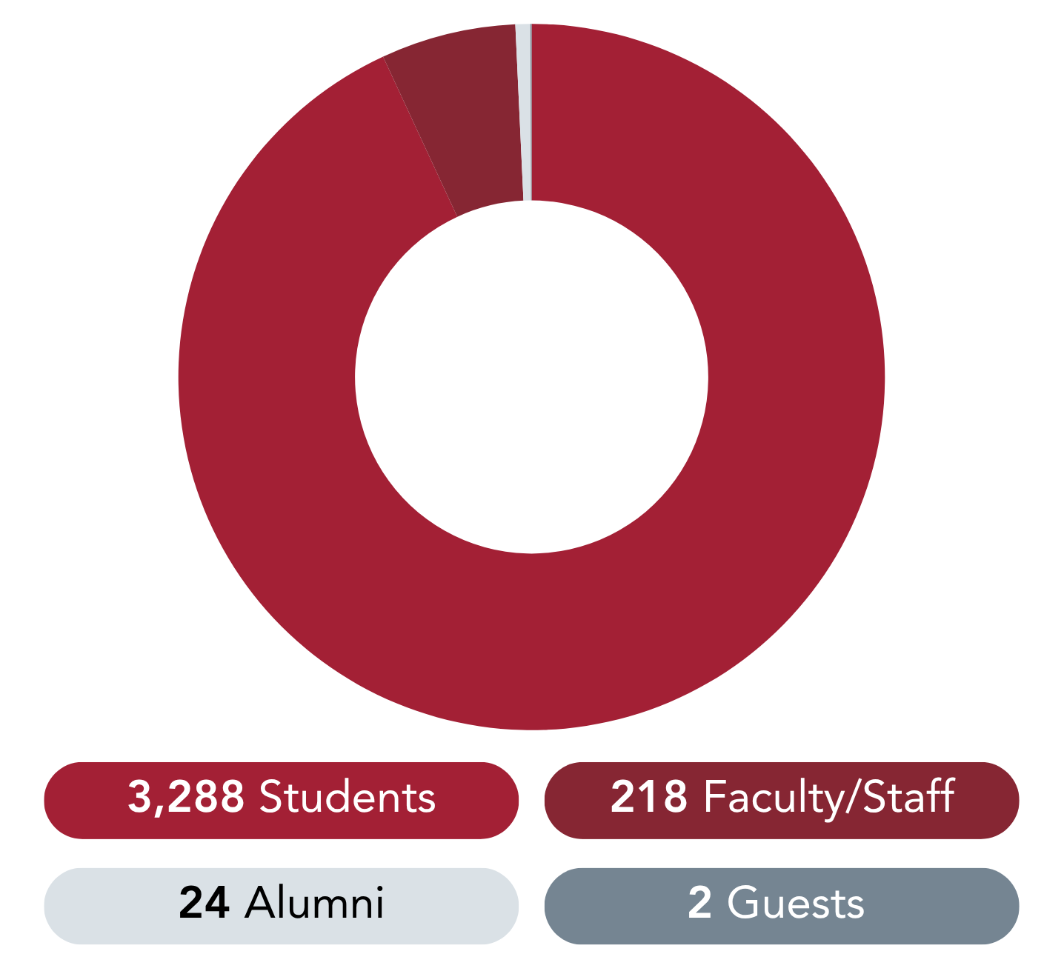

Bronco Kids All Sports Camp
The Bronco Kids All Sports Camp (BKASC) held 6 sessions from June 17 to August 2 (no session July 1 to July 5)

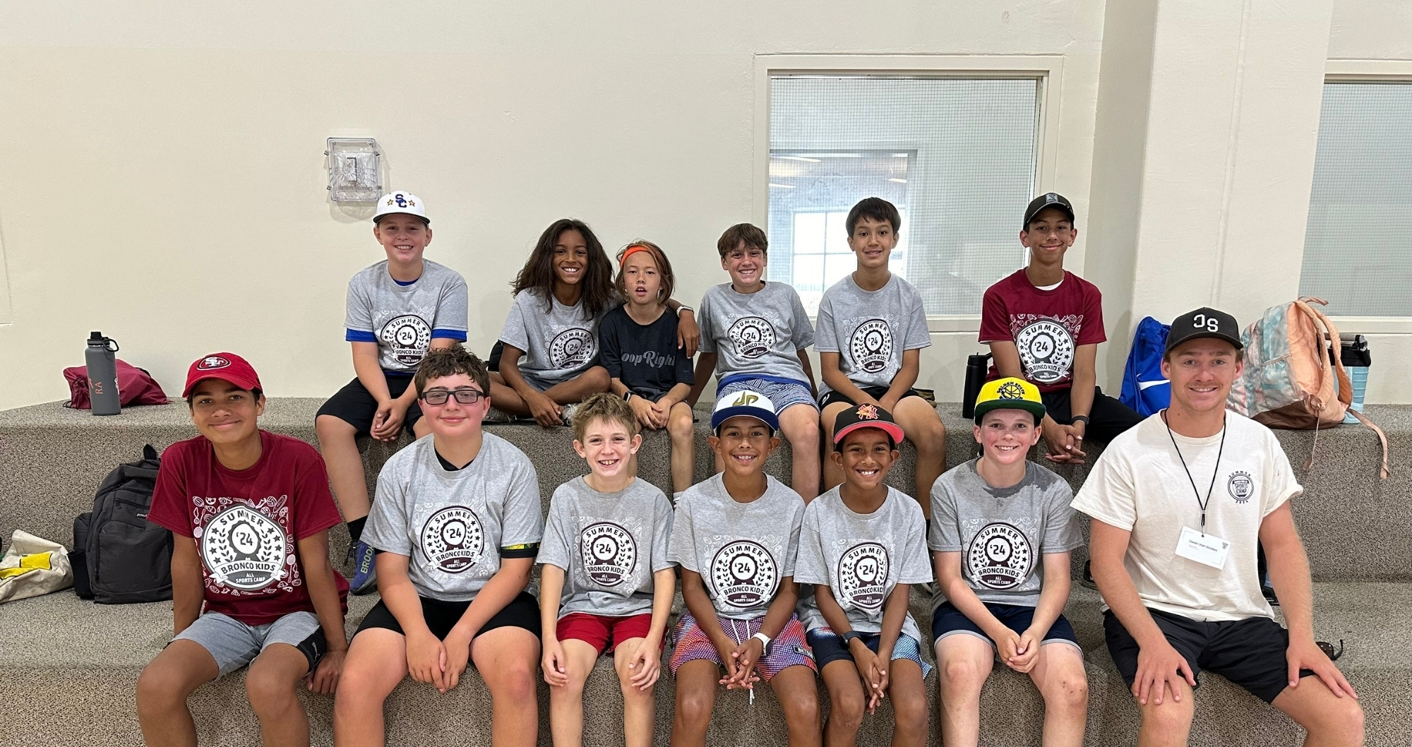
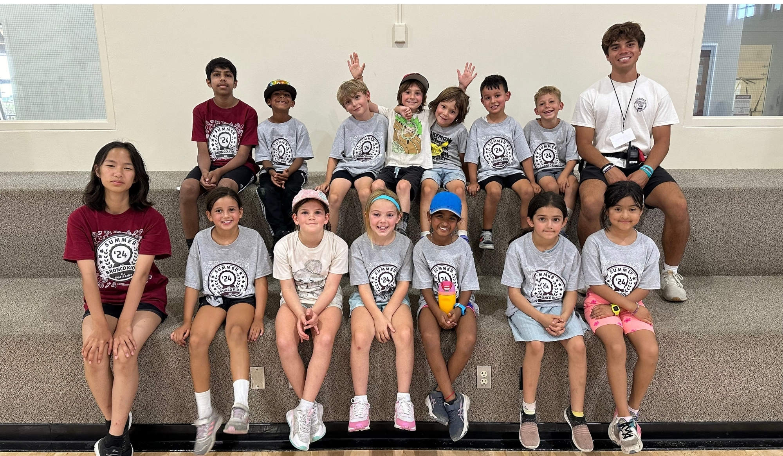

Total Gross Registration Revenue
$262,807.72

Total Campers
576

Percentage Increase in Total Campers from July ‘23 - June ‘24
12.5%

Total CITs (Counselors in Training)
95

Total Camp Coaches
14

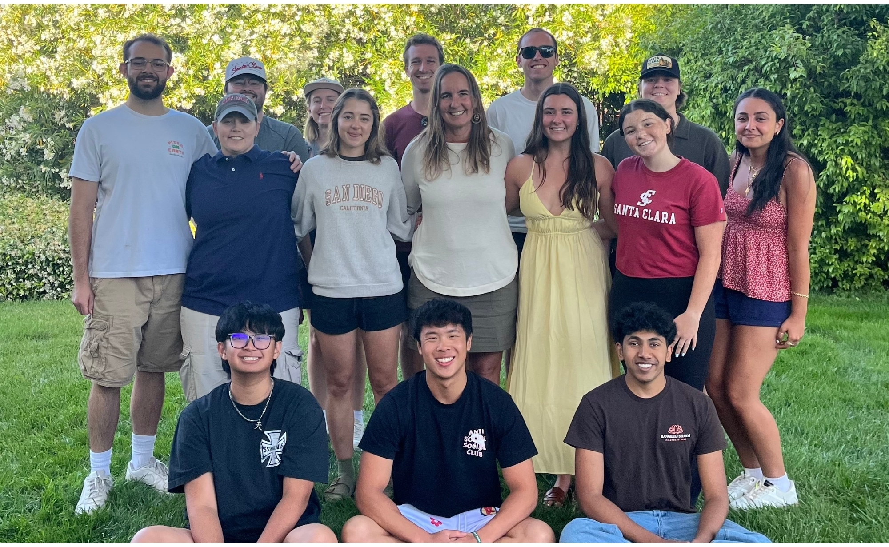

Student Employment
Campus Recreation has a total of 150 student employees.

Additional Statistics
76 of the 150 student staff were new hires.
25.3% of our student employees were eligible for Federal Work Study

Student Staff by the Numbers
Student Coordinators: 13
Facility Supervisors: 24
Membership Services: 17
Weight Room Attendants: 19
Lifeguards: 30
Intramural Supervisors: 13
Intramural Officials: 26
Bronco Kids All Sports Camp Staff: 28
Club Sports Event Supervisors: 5
Fitness Instructors: 5

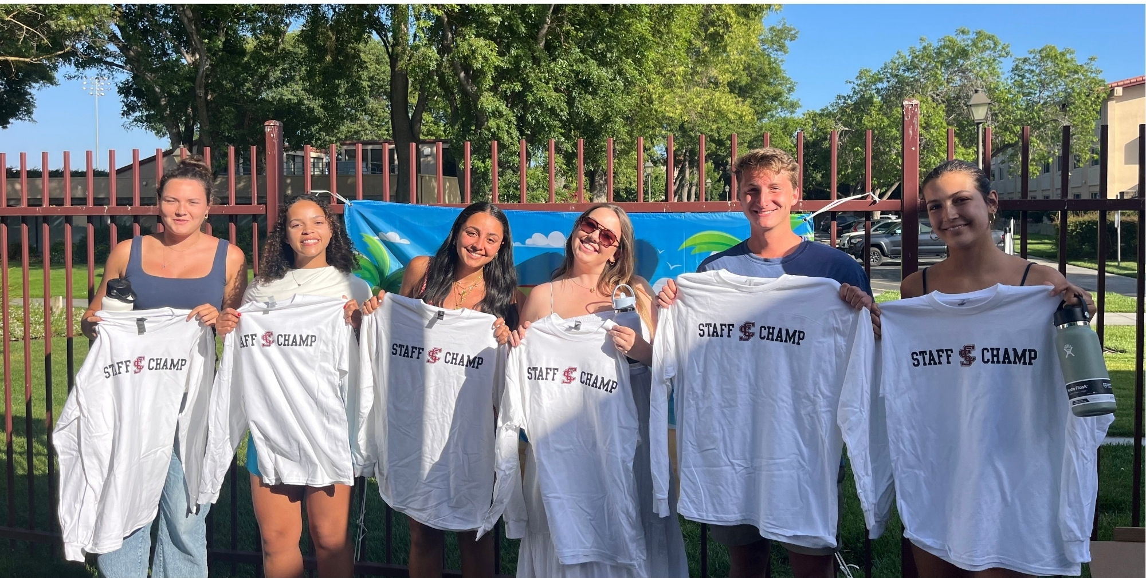

Staff Champs are voted each quarter by all student staff in each area. Staff Champs are rewarded with a long-sleeved t-shirt and a Hydroflask water bottle. We awarded 25 Staff Champs during the ‘24 -’25 academic year.

